A Guide to using the Betfair website



Ever wanted to use internet exchanges but weren’t sure how to? Well in this eBook put together by staff at Betfair you’ll learn all the tricks of the trade to making the best use of all the facilities the website offers. From opening an account to finding out about all the different ways you can bet on Betfair – this eBook should have you covered.

Chapter 1 – Introducing Betfair…2
Chapter 2 – Starting Out…5
Chapter 3 – Managing Your Account…12
Chapter 4 – Choosing Your Market…21
Chapter 5 – Placing Your First Bet…30
Chapter 6 – Doing the Maths…37
Chapter 7 – Betting In-Play…39
Chapter 8 – Using Betfair Starting Price…45
Chapter 9 – Poker, Games & Casino…49
Chapter 10 – Finding Information…51
Chapter 11 – Low Risk Betting: Trading…53
Chapter 12 – Low Risk Betting: Arbing…59
Chapter 13 – Going Pro…61
Chapter 14 – Controlling Your Gambling…74
Chapter 15 – Ten Common Mistakes to Avoid…79
Chapter 16 – Ten Top Tips…83
Chapter 17 – Ten Sporting Information Sources…88
Chapter 18 – Ten (or so) Amazing Markets…93
Chapter 19 – Ten Betfair Firsts…99
Chapter 1

Betfair – www.betfair.com
Betfair continues to be one of the fastest-growing online betting companies in the world. Its popularity however can probably be credited to its online betting exchange. A betting exchange is an avenue for people to pick who or what they think will be the winner and bet against each other on it. This is all made possible by the brilliance of the technology invented in the late 1990s, by Andrew “Bert” Black.
What is Betfair? Basically it’s a barman managing bar betting but on a global scale; he’s the barman to the world. The barman helps people bet against each other on just about anything they have an opinion on and want to wager on the outcome.

Betting Revolutionized
Betting opportunities differ depending on laws and regulations in place within a country. It’s even illegal in some countries to bet.
In the dark ages, pre Betfair, there were two main outlets available to place bets on sports. Fixed odds bookmakers and pool betting operators were really the only avenue to place a bet.
Pool betting operators and sweepstakes work very much alike. People put money into a pool that is for a specific event. The PBO usually takes a 20% cut and what is left is split between the people in the pool who chose the winner of the event.
Pool betting has disadvantages:
- One, the odds can only be determined by the number of people placing bets in the pool.
- Second, when the contest starts, the pool closes.
- Third, the PBO’s cut can drop the winnings, and the odds can drop drastically by the time the contest starts so you may end up with terrible odds.
Fixed-odds bookmakers business is based on fixed odds. FOBs set their own odds on a variety of sporting contests and make a book (place odds) on events of their choice within a contest. For instance you can place a bet on the result of a tennis match, but you can also wager on each game and set. More times than not a person can take a price which means the bettor knows the odds to be settled if there is a win. A FOB build in a margin to make their money so there is no pool to take a cut from.

Entering Betfair
When the late 1990s entered, Andrew “Bert” Black came up with an ingenious idea to use the practices of the stock exchange to model betting against and change it forever. He created a way to back and lay (buy and sell), the outcome of sporting events comparable to buying and selling shares in the stock exchange. With business partner Edward Wray, in the year 2000 his idea was launched.

What does the Exchange Offer Me?
This is probably the most important question from all the questions you may have. Betfair offers you four main benefits that are outside what more traditional betting offers.
- Confidence you are getting the best odds.
- You can bet and lay.
- You are not closed out since you can bet in-play.
- You can be sure your account will not be closed down by Betfair just because you win.

Better Odds
A person betting gets better odds because they are not betting with a bookmaker but against other individuals. This means there is no built in margin for a profit by a bookmaker. At Betfair a bettor is matched up against another bettor who has a different opinion on the outcome. The person wants to win, but uses no caution when setting the odds like a professional bookmaker who need to build in a big profit margin.
On Betfair, you have a higher chance of getting better odds because it’s only two people betting against each other. Also, there are times you may get odds better than you could ever think possible on a long shot. A customer may feel the long shot has a chance to win too so, he may back it with something like 500 because someone else was prepared to lay high odds.
Another good example of how the odds can work in your favor is when there can only be two outcomes like in a pool game or table tennis match. On Betfair the odds are about 4% better than the approximate 2% you’d get with a bookmaker.

Back and Lay
A back means you are backing something to win and a lay means your prediction is it will not win; a bookmaker does not let a bettor do this. Not only is this allowed at Betfair but, Betfair knows this is a key factor to you becoming a successful winning gambler. Betfair’s practice of a back and a lay are much like buying and selling in the market where a person buys low and sells high to make a profit. A bettor having the flexibility to back and lay gives them endless opportunities to make some money gambling.

In-Play Betting
In-play betting is Betfair’s baby; they have pioneered the practice of betting while the event is currently in progress. Betfair provides this unique betting on tennis, soccer, horseracing, cricket, and more – allowing a bettor to bet right up to the very end of a contest. This is very useful for a bettor who moves quickly to change a bet on a contest in progress.

Winners Are Always Welcome
Bookmakers are not fond of a bettor consistently winning and collecting money from them. A bookmaker may decide to not take bets from a bettor who had had “Lady Luck” on their side and close the door so to speak. Betfair will never close the door and an account is never limited because a bettor happens to be a frequent winner.

Chapter 2

Anyone can win on Betfair, but first it is essential to have the right equipment. You’ll need:
- A Computer (Mac or PC – the more memory your computer has and the faster it works, the quicker Betfair will work.)
- An Internet Connection (Betfair works best with broadband or ISBN and any browser can be used)
- An Active Betfair Account
- Money in Your Betfair Account
Betfair can be used on a dialup Internet connection but since split second decisions are often needed to win Betfair works best with a high speed Internet connection.
Betfair knows you are not always sat in front of your computer and has the technology to let you carry Betfair around in your purse or pocket. You can download Betfair Mobile for free on most modern cell phones. You can log into your Betfair account, view the odds, make bets, and if you want you can withdraw money from your Betfair account all from the convenience of your cell phone. You can get all the details at http://mobile.betfair.com.
The Betfair Helpdesk is available for any issues or technical questions you may have. Call 0844 871 000 for assistance.

How to Open a Betfair Account
Before you can begin to bet and start to win on Betfair you will first need to open up an account. This all starts at http://betfair.com.
Follow these steps to open an account.
- Go to http://betfair.com
- Click the on “Open an Account” link to open the new user registration window.
- Complete the form by entering the personal and account information needed.

- Name
- Date Of Birth -- Betfair is legally responsible to confirm you are 18 years of age or older
- Contact Telephone Number -- Used only if Betfair needs to contact you about your account.
- E-mail Address -- Used only if Betfair needs to contact you about your account.
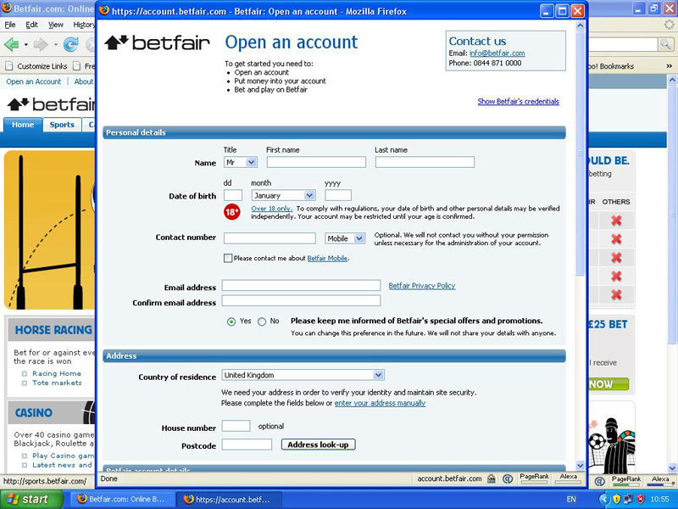
- Choose Yes or No to let Betfair know if you would like them to send you special offers and promotional marketing information. Please note you can change this at any time and Betfair will never provide your private personal information with anyone. The information Betfair supplies you can be very useful; you’ll receive articles, statistics, and TV schedules of the week’s sporting events. All of these can be a benefit to you and keep you from being at a disadvantage when compared with other Betfair customers.

- Country of Residence and Address Details
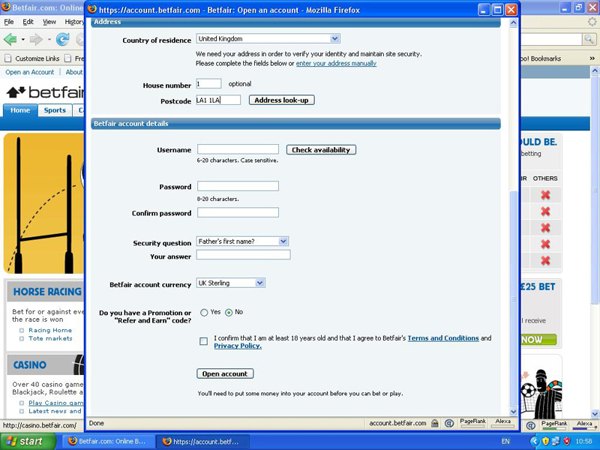
- User Name and Password -- This will be used every time you log into your Betfair account so be sure to pick something unique but something you will easily remember. Do not forget to make your Password something no one else can easily figure out. It is best to include a combination of letters (CAPS and lowercase), numbers and special characters such as %, #, or *. This will help make your Password more secure.
- Security Question -- This will be used to confirm your identity if you forget your password. Be sure to select questions and provide answers that cannot be easily guessed by others. Note -- Betfair will never ask you for your Password or security question by email. If you ever receive an email asking you for this information, contact Betfair immediately to report this.
- Promotional Code or Refer and Earn Code -- Betfair offers free betting to new customers often so they can try betting without risking any of their money. If you have one of these codes, be sure to enter it carefully when registering so the system recognizes the code.
- Next type the characters into the box just as they appear to confirm you are a human and not a hacker trying to get access to your information and control your account.
- Read and confirm you agree with the terms and are 18 years of age or older.
- Click Open Account.
Once you have completed all the steps from above a page will open about funding your account. Here is where you will deposit money into your account. Betfair helps a customer control their money by allowing them to set limits on deposits and losses. You’ll find this link located at the top of the funding page and can change the limits at any time. Note -- changes that are decreases happen instantly but an increase takes 24 hours to take effect.
Always be sure to log out when you are finished betting on Betfair and close all windows when you go away from your computer.

Deposit Money into Your Account
Once you have successfully registered and are the proud owner of a Betfair account it is time to add funds so you can start betting. The Funding page gives you four main funding options:
- By using a credit card or debit card -- When using this option be sure the Card Nickname you enter is the name exactly as it appears on the card. This way if you register more than one card you will have no trouble keeping which card you want to use separate from a different one registered on your Betfair account.
- By using a direct bank transfer
- Through PayPal – Enter your PayPal account information.
- Other means -- If you are unable to use a debit or credit card you can find out more information about alternative methods by visiting http://payments.betfair.com.
Using one of the methods above, you may now enter an amount you wish to deposit into your Betfair account. Note -- If using a credit or debit card to fund the account you will also need to enter the 3-digit security code on the back of your card. Once you have selected and entered all required information to deposit money, you can then click Next.
Some cards require a 1.5% charge be made on all deposits. If you are unsure this charge will apply to your card please contact the Betfair Helpdesk to inquire. After the first time you have deposited funds into your account all of your card’s details will be stored; future transactions will be an easier process.

How to Put More Money into Your Account
- Click on the “My Account” link located at the top of Betfair’s homepage. (This is a pop-up)
- From the menu on the left click “Deposit Funds”.
- Enter:
  - Amount to be deposited
  - Your Security Code
  - Your Account Password (Click the “Forgotten Password” link for help if you have forgotten your password.)
- Click on “Make Deposit” (The funds appear in your account instantly.)

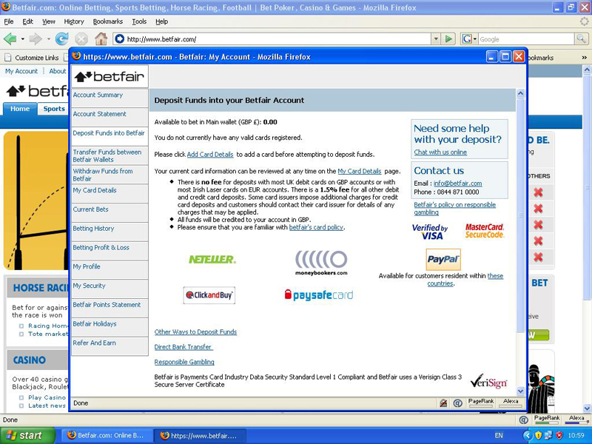
Withdraw Money from Your Account
Hopefully with the help of this book you’ll be withdrawing money on a regular basis you’ve won on Betfair!
Withdrawing money on Betfair’s homepage is simple; just follow these steps:
- Click on the “My Account” link located at the top of the page. (This is a pop-up)
- From the menu on the left click “Withdraw Funds”
- Enter:
  - Amount to be withdrawn
  - Select which card the funds are to be credited to.
  - Your Account Password (Click the “Forgotten Password” link for help if you have forgotten your password.)
- Click on “Withdraw Funds” (The funds appear in your card’s bank account usually within 2 to 5 days.)

Chapter 3

Manage Your Account
Betfair keeps a log of all your bets, including wins and losses. You’ll also find Betfair makes navigation easy; revisiting pages you have already been on and to get to those you haven’t been on during this session is something Betfair makes easy too. This is only one of the reasons using Betfair is a breeze.

Working With Your Account
The “My Account” section is where you will manage your account details. You must first be logged in to access the “My Account” information.
Logging In:
- From the Betfair homepage, http://betfair.com click inside the white box that says “Username”.
- Type in your Username.
- Click inside the box below that says “Password” and enter your password.
- Click “Login” or hit the Enter Key on your keyboard.
You have successfully logged into your Betfair account and can view your account information by selecting “My Account”. You will have 14 menu options to choose from once the Account screen pops up.

Account Summary Information
For a brief overview of what is going on in your account look to the Account Summary page. This page holds the balance of your account and your current exposure. Any unsettled bets you have is your current exposure and this subtracted from your balance is what money you have to bet with or withdraw from your account.
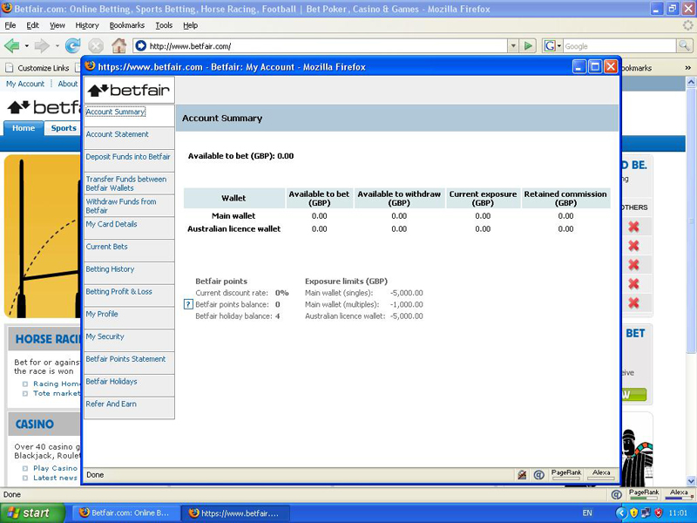
The Exposure Limit is a figure pre-set to prevent you from betting more than a specified amount in any one period. £5000 is the default setting, but if you’d like to adjust this amount you simply call the Betfair Helpdesk on 0844 871 0000; they will be happy to assist you.
The page also holds the number of Holidays and Betfair points you have along with your current discount rate.

Your Account Statement
Your “Account Statement” keeps a running progress of your account’s previous month; what money you have transferred in or out, any bets you have placed, and the commission you have paid. You can think of your Account Statement as being similar to your bank statement.
You can determine which entries are listed on your Account Statement by filtering out those you don’t want and leaving the ones you do. In other words, you can have just your Poker Room activities or the deposits and withdrawals listed just by selecting these options from the drop-down menu available.

Depositing Funds
Depositing funds into an existing account is an easy process. You only need to enter the amount you wish to deposit along with the credit card’s security code and simply click “Make Deposit”. This money will appear in your account instantly.
Tip: Whenever possible, deposit money with a debit card, it costs the least and is the easiest way to get money into your betting account. However, if you scroll further down the page you will find additional deposit options such as PayPal and Moneybookers.

Transferring Funds
Betfair has what is similar to bank accounts, these are called wallets. Depending on what you wish to bet on, this means you are able to split your money up into different pots. Betfair is a Global operation so there are different wallets for the Casino and Games areas, and for UK and Australian markets. If you’re going to bet on these then you’ll need to transfer money into these wallets. If you see an Australian flag located in the Rules area of the market view, this means it is the Australian market.
Money can be transferred quickly and very easily:
- At the top of the page click the “Transfer” button. (A popup occurs that asks how much you wish to transfer.)
- Choose the wallet you’ll transfer money into then enter the amount you wish to transfer.
- Click “Make Transfer”.

Withdrawing Funds
You’ll find every debit and credit card you have registered with you Betfair account.
You can withdraw money by:
- Enter the amount you wish to withdraw.
- Enter your Password.
- Click “Withdraw Funds”.
Withdrawals can take 2 to 5 days to register to your card’s bank account.

Your Card Details
Registered cards can be managed in the “My Card Details” option. At any one time up to 3 cards can be registered. The details of a card can be changed at any time by selecting “Modify Card Details”.
A new card can be added simply by clicking “Add Card Details” and entering the card details. Betfair suggests placing Nickname that matches the card to minimize confusion when making deposits or withdrawals to a card.

Your Current Bets
One option found to be a very useful feature is the Current Bets option. This allows a person to quickly see what bets and events they’re currently involved with.
They can choose whether to view bets placed on the exchange or any multiple bets they may have.
Select the bets you want to view from the drop-down menu, unmatched or matched. A full list is shows the market of the bet, the selection, if it's a back or lay bet, how much has been staked, and the odds.
Click the underlined market name to review a bet in more detail.
Unmatched bets can be cancelled in the Current Bets section.
- Use the tick box to select a bet.
- Click Submit.
This automatically cancels any unmatched bets.
Your Betting History
Your Betting History holds all the bets you have placed for the past three months.
You can search for a specific bet by selecting the type of bet you want to search for from the drop-down menus. You can do this by choosing which sport and the specific date range then clicking on Get History.
It is possible to print out a spreadsheet to analyze multiple bets. Simply click the link Download to Spreadsheet to save the search into a Microsoft Excel document.

Your Betting Profit & Loss
With your Betting P&L you can view your profit and loss history over the past three months.
- Select Time Period to Search By
- Click “Get P&L”
  - At the top of the page your profit (assuming you win) or your loss appears by sport.
To see a rundown of your P&L for any of the markets you have placed bets on, click on any sport listed.

Viewing “My Profile”
My Profile holds all your personal details Betfair has on record about you. To update these do the following in the relevant section:
- Click Edit
- Click Update

Viewing “My Security”
My Security has a complete list of:
- All computers that have logged into your account.
- What day the computer logged into your account.
- What time the computer logged into your account.
This can prove helpful to be sure you are the only person accessing your account.
Note: If you ever notice a computer you don’t recognize, change your password immediately and contact the Betfair Helpdesk.

Your Betfair Points Statement
The commission Betfair collects is based on your number of Betfair Points.
The Betfair Points Statement holds all the points you have earned. You search up to three months of your BP History records by selecting from the drop down menu.

Betfair Holidays
Your Betfair Points depreciate on a weekly basis by a rate of 15%. If you use your account regularly, this should have no effect on. If you are not going to access your account for a week or more, then you may want to book a Betfair Points Holiday to prevent the total of your points being reduced.

Refer and Earn Scheme
Betfair’s Refer and Earn Scheme is a useful way of supplementing your account’s betting bank. When you refer a friend and they open a Betfair account using your unique “Refer and Earn” code, you get paid money.

Customizing Your Betting
There are about 7.000 markets to bet in available on Betfair weekly. You have a huge selection to choose from to bet on.
The “My Markets” allows you to customize your favorites you bet on and houses them all in one place for you. This will save you a lot of time.
On the Sports homepage follow these follow these steps to organize and set up your “My Markets”:
- On the left hand side of the screen, click My Markets. (Popup with a list of all the sports and events to bet on opens.)
- Select the market(s) you use on a regular basis.
- Click Save (located at the bottom of the popup.)
From now going forward every time you log into your account, you’ll see the sports or events you set up in your menu.
TIP
On the Sports homepage you can use the Market Search, top left, to find a team or runner name you are interested in. This will produce all markets that include the name in your search.
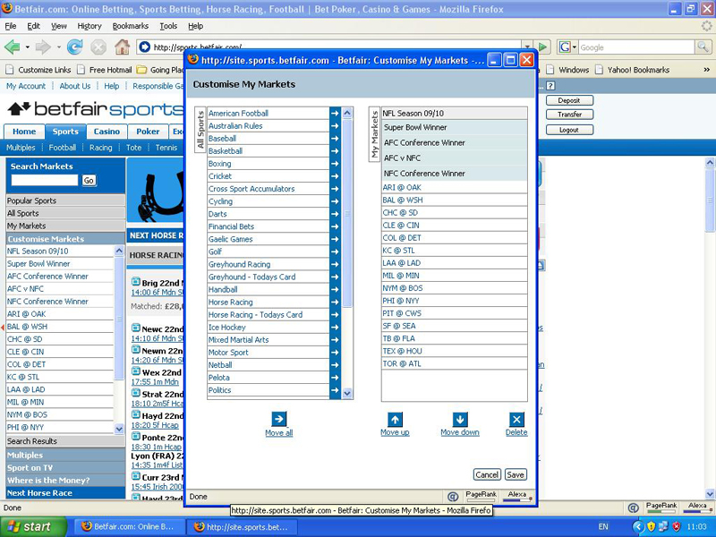

Be a Part of the Betfair Community
The Betfair forum community is different than other online chat rooms. The Betfair Forum is a little bit different. Once you get through the drivel you’ll find discussions on betting and sports that can prove very helpful. You’ll just need to pick out who it is that really knows what they’re talking about.
The community is very helpful to new members who are trying out this betting thing for the first time and have questions. Others in the community are either experiencing the same things you currently are or have already been through it and may have some really good help to offer.
You can access the Betfair Forum at any time from the homepage. Just click Forum located at the top of the page. There are three main sections:
- Announcements: You’ll find information from Betfair here.
- Sports: Post and read comments on a variety of sports betting here.
- Other groups: Post and read comments on every topic you can imagine!

Create a Chat Name of Forum Name to post in the Forum:
- Select a sport or category of interest to you from the Groups menu on the left-hand side of the Forum.
- Click the Create Topic button (top right of the screen).
- Choose a Forum name.

For security reasons:
- Make sure your chat name is very different from your Username and Password.
- Make sure your Forum name is very different from your own name if you want anonymity.
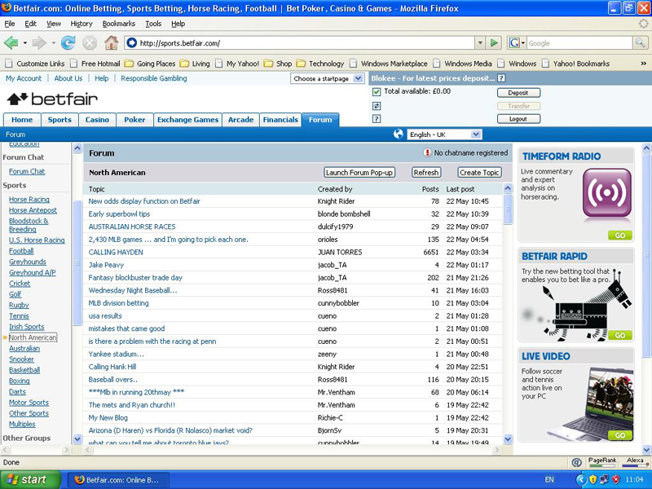

Chapter 4

Selecting Your Market
One of the things that make for a great betting opportunity is reality TV. It is an innovative and engaging insight into the general public daily lives. There are also those celebrities that allow the public to intrude into their otherwise very private lives. This offers the perfect opportunity to bet on who will do what or what will happen next!
This is just one possible market to bet on. There are a lot of markets to choose from to bet in on Betfair. Just be sure you do your homework on any market you bet on. In this chapter you’ll see some different ideas of the types of betting events to bet on and how to locate the market(s) you want to be in on Betfair. There are many different market styles available to choose from.

Betting: From American Football to Yachting
Betfair matches up people with different opinions. This doesn’t mean it’s a free-for-all; Betfair doesn’t try to match up every request a customer has. Instead, Betfair has a list of interests their members can choose from to bet on.
Betfair also makes sure all the rules of any bet are clear. For example, does he have to cross the finish line within a certain amount of time or does it matter what color uniforms they wear this time?
Betfair cannot offer this service for every bet a person might make. With all the markets a customer can bet on, it would be a great deal of effort for Betfair with no reward.
Betfair bases the selection of their available Markets on previous experience with what customers like to bet on. Betfair welcomes suggestions from their members on new markets to try. Just know markets are closely monitored and if their not being bet on, most likely they won’t be tried again.
There is a range of many things you can place bets on in four different categories: politics, specials, sports, and financials.

Bet on Sports
The majority of betting on Betfair is Sports betting. Along with soccer, horse racing, greyhound racing, tennis, cricket, golf, American sports, sailing, badminton, chess, and bandy (type of hockey played on ice) just about any sport you can think of is available to bet on at Betfair.

Bet on Financials
Increasingly over the past 20 years financial betting has become very popular. You’ll find a large choice on Betfair of financial markets to select from and bet on. Some of the stock exchanges include New York, London, and Frankfurt to name a few. You’ll also find interest rates, oil prices, and house prices too.

Tip
If your betting preference is financials, then Betfair is your place. Betfair has a sister site at www.tradefair.com that might be of interest to you. It offers a multitude of different ways to bet on financial markets, this includes binaries and spreads.

Bet on Politics
Politics is increasingly becoming a popular bet – for the 2004 U.S. Presidential Election over £19 million was matched on it.
You’ll find a complete range on Betfair of markets to bet on for a would-be politico. Markets included are:
- Who will be the next leaders of parties
- Who will win elections
- What the result of important votes will be
- All things involved

Bet on Specials
Anything that does not fit in one of the existing categories is “special betting”; it’s considered a catch-all area. Some of the markets that fall into this area are award ceremonies, TV shows, weather, and Miss World.
Some things you may find not so normal to bet on are:
- “Next Manager” of a soccer team
- Whether Finland will or will not have a white Christmas

Getting to a Betting Market
You can get to the market you want in two ways:
- Use the Menu
- Use the Fastlinks

Using the Menu
The menu is always located on the Sports homepage to the left side of the. Access a market by simply clicking the event of interest. Note: There are some sports with many categories and sub-menus you’ll go through to reach the market you want to bet on.
My Markets – Add and Subtract Events the Speedy Way
(There is a plus sign after each market name.)
- Click on the plus sign
(The plus sign becomes a minus once added.)
- Click the minus to remove.

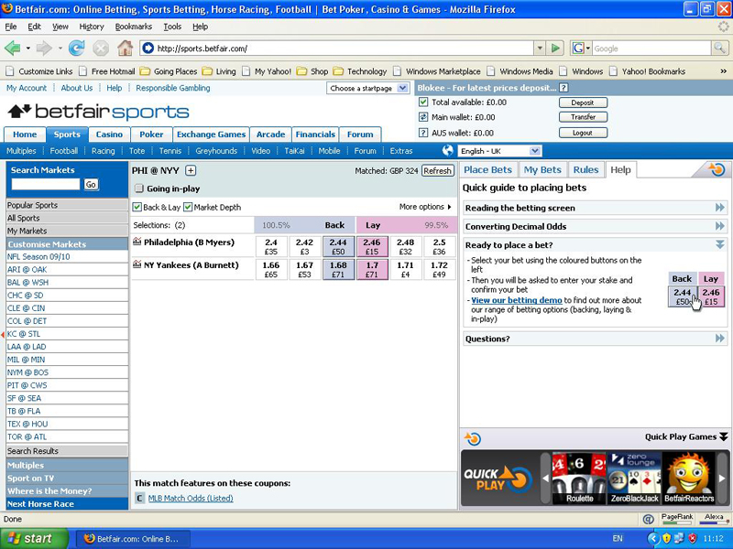

Use Search Markets
On Betfair the Search Markets button lets you to search all the markets for a specific name. This means you can enter an athletes name or a team name in and search to find all the markets you can bet on them in.
The Search Markets box is located on the Sports homepage above the menu.
Using Fastlinks
Getting to markets from the Sports homepage is conveniently done by using the fastlinks. These are direct links that quickly and efficiently get you to your markets of interest.
Betfair’s team works to keep your country’s most popular markets at your finger tips. They’re just a click away from the center of the Sports homepage. This is where you will find your favorite sports to place bets on.
On the homepage, listed on the right hand side, you’ll find your most markets viewed, in-play opportunities coming up, and those events about to start. Click the one you have an interest in betting on.

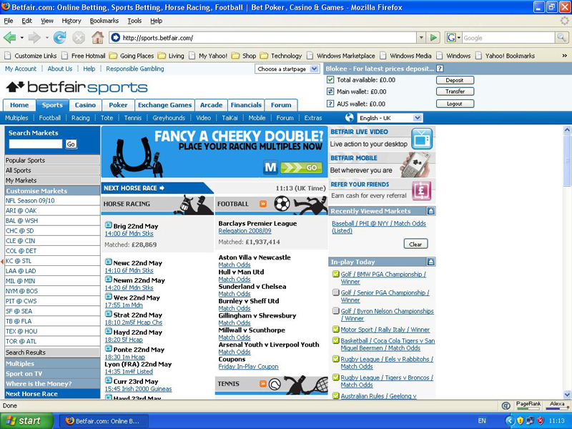

Understanding the Different Types of Market
The majority of markets on Betfair are simple and straightforward. For the most part you’ll be predicting the outcome of an event. For example, you’ll decide if you think a team will win, lose, or tie.
One of the most important things to remember is to always be sure to read a market’s rules before betting. Completely understanding the rules is key to winning or losing. All market rules are always located on the right hand side of any screen under the Rules tab.

Place markets
Place markets are run for many different kinds of events and are those markets that allow a person to bet on events that have the possibility for multiple winners. Some of the place markets also have the possibility for a number of possible outcomes. For example, in a basketball game, what 3 players will be the top scorers?
When betting in place markets there are two crucial things to remember.
- Check the markets Rules section to find out how many places are available.
- “Place” also includes 1st place in addition to 2nd and 3rd, etc.

Betting in Handicap Markets
A handicap market is a market that theoretically gives a selection or team a head start against all of the other competitors. You’ll find a handicap, from a betting standpoint, makes an event more interesting and/or can eliminate any possibility of a tie.

Make Things Interesting
Some sports aren’t very “eventful” so on occasion Betfair will place a handicap on a team. If a handicap of 17.5 is placed on a team this means they have 17.5 virtual points at the start of the game. The team they are playing will need to have at least 18 points more than the handicapped team at the end of the game to be the winner. (The half point is given so prevent a draw.)

Asian handicaps
Asian handicap is a type of soccer betting that first began its popularity in Asia, but is becoming common in other areas of the world. There are two primary Asian handicap bets.
- In the first there cannot be a draw. This is accomplished by Betfair giving a team a -2.5 handicap. At the end of the game the -2.5 will be added to the team’s final score.
- In the second a draw can happen and will void the bet. This can happen if Betfair gives a whole number handicap, -2.0, 3.0, etc.

In some cases Betfair will give a team two handicaps. If one is a -0.5 and the other is -0 you’ll divide the state between the two handicaps. For example, if you bet £150 on a team with -0.5 and -0 handicaps, the bet is actually £75 on one and £75 on the other.
.
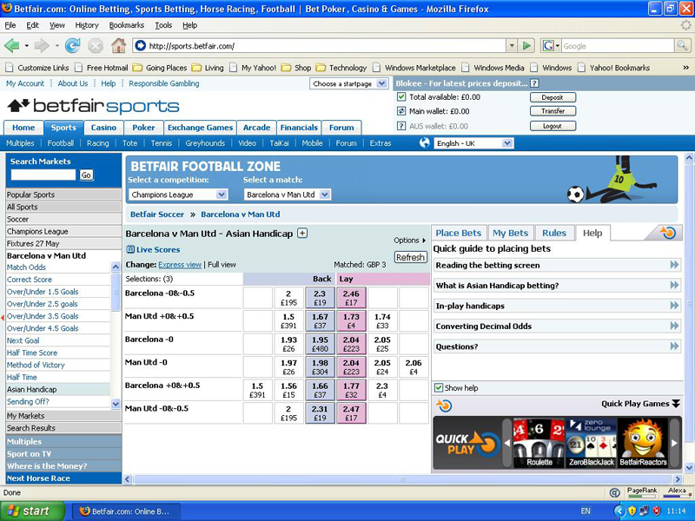

Multiples betting
Multiples betting is something bookmakers commonly offer. Betting on multiple events together is known as an accumulator, the higher the number of events the higher the odds. This is where you can win big with a small bet. At Betfair you’re allowed to back or lay the accumulator. This means better odds.
You can find out which markets are available on Betfair for Multiples betting under the Multiples tab on the Sports homepage.
Range betting
Range betting asks you to Buy or Sell a specific value when betting on the total number of goals, points in a contest, or runs. The difference between the amount you placed a bet with and the actual total is your profit or your loss.
There is always a maximum and a minimum score when range betting, this is so a person always knows how much their winnings or losses are. You can find the details for this in the Rules tab of any market (located on the right side of the screen).

Line betting
Line betting is even money betting whose total does not depend on the final total of a particular contest.

Chapter 5

Placing Your First Bet
Before you can place your first bet you need to know a few basics. In this chapter you’ll learn how to place a bet, how to back and lay odds, and how to determine how much commission from your winnings you’ll pay Betfair.

Understanding the Basics
- A bet is risking a certain amount of money on your prediction of an outcome of a future event.
- A bet must have two parties – a backer, someone who thinks one thing will happen and a layer who thinks it will not happen.
Any bet consists of four key elements:
- The stake – the amount of money the backer is risking.
- The odds – the rate at which the bet will be calculated at. Decimal odds are used by Betfair (I.e., 1.43, 5.2, and 60.0).
- The return – the amount of money the backer gets back if he made the right prediction. Returns include the stake and the profit. Calculate the return of any be by multiplying the stake by the odds.
- The profit/liability – the amount of money won by the backer if his prediction is correct. Calculate the profit by subtracting the stake from the return. (This is also the amount of money the layer loses.)

Back and Lay
This is Betfair matching people together with opposing views about a particular event. You need a backer and a layer to match each.

Backing
Backing is where you stake money on something you believe will happen and you’ll make a profit if you’re correct. Just make sure you understand a market’s rules you’ll be betting in.
The easiest way to understand backing is by placing a first bet. Follow the steps bellow:
- Get to a market you would like to bet in. (See Chapter 4 if you need help finding a market you’re interested in.)
- Select the event you think you’ll win and want to.
- The blue box – has two numbers in it.
  - The top number – the amount of money you have available to back the selection at.
  - The bottom number – the amount of money you have available to back at those odds (the maximum stake you can have on).
  - The amount below the odds is the amount of money you have available to back at the odds (you don’t have to bet this amount and can bet as much or as little as you like).
- Click the blue square. You’ll see the bet you’re requesting on the right side of the screen.
- In the Place Bets tab click the Your Stake on the right side of the screen.

- Enter the amount you want to stake on the bet.
Since this is just a practice bet you’re placing, we suggest you use the minimum stake amount Betfair allows of £2.
- Click on Place Bets.

Betfair displays a screen to confirm you’re happy with the bet.

- Click Yes if you agree with the bet.

Congratulations! You have made your first bet on Betfair!
The series of green or red numbers you see under each selection in the market. The numbers indicate how much you win or lose. Green you win – red you lose.
Laying
Laying is the opposite of backing. Laying is betting money that something won’t happen and making a profit if you are correct.

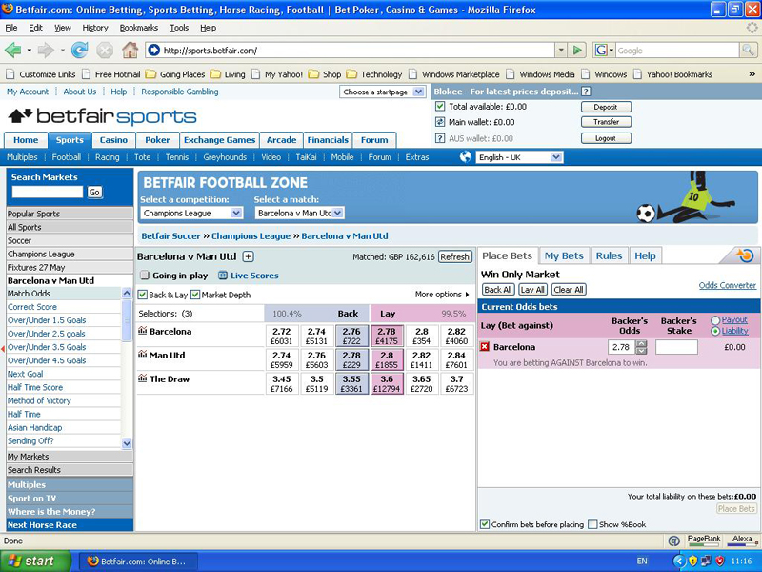

The amount of money you enter is not the amount you are risking; instead it is the backer’s stake you’re willing to accept at those odds. The backer’s stake multiplied by the odds is the same as the amount of money you’re risking. For example, if you lay £200 at 1.86, you’re risking £172 (200 x (1.86 – 1)). Lay betting is similar to back betting.

- Get to a market you would like to bet in. (See Chapter 4 if you need help finding a market you’re interested in.)
- Select the event you want to lay.
- The pink box – has two numbers in it.
  - The top number – the best odds you have available to lay your at.
  - The bottom number – the amount of money you have available to lay at those odds.
- Click the pink square. You’ll see the bet you’re requesting on the right side of the screen.

- Click the Backer’s Stake box.

- Enter the stake amount you want to accept on the bet.

Since this is just a practice bet you’re placing, we suggest you use the minimum stake amount Betfair allows of £2.
- Click Place Bets.
- Click Yes if you agree with the bet.

Congratulations! You have made your first lay bet on Betfair!
The series of green or red numbers you see under each selection in the market. The numbers indicate how much you win or lose. Green you win – red you lose.

Ask for better odds.
You can ask for better odds than the currents ones being advertised if you don’t want to place a bet offered by other Betfair customers. Having this option allows you to see if any of the other Betfair customers are willing to take you on. If your price is reasonable you’ll chances are good someone out of the thousands of other customers on Betfair someone will take you on.
Follow these steps to ask for bigger odds:
- Get to the market of your choice.
- Choose a selection you want to back.
- Click the blue square.
  - Your bet appears on the right side of the screen.
- Click the Backer’s Stake box on the right side of the screen.
- Enter the stake amount you want to place on the bet.

- Use the Your Odds box arrows to adjust to the odds you want.

- Click Place Bets.

- Click Yes to confirm your bet.

Congratulations!

To lay a selection at a lower price, decrease the odds you offer in Step 6. If you’re laying you want smaller odds to decrease your liability.
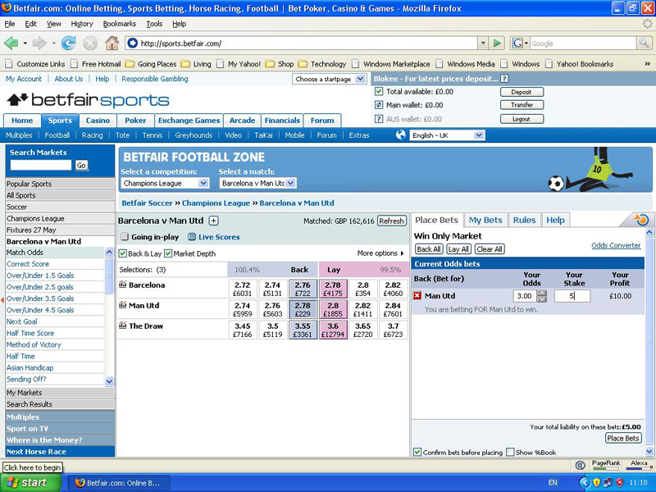
Matched Bets and Unmatched Bets
Betfair’s purpose is to match people up that have different opinions about how an event will play out. These matched people make a bet. However, it’s rare that one person is matched directly against another. In reality, it’s more common that one person is matched up against many people.
You can review your bet by clicking the My Bets tab on the right side of the screen. You can see the amount of your bet that has been matched and unmatched.
You can cancel or adjust the odds or the stake on any part of bet that is unmatched and the resubmit your bet. Just be aware that when resubmitting a bet it will go to the back of the queue.

Paying Commission
Betfair makes money by charging a bettor a commission on their net winnings in a market. However, if you lose money, you pay no commission.
Market Base Rate – Every market on Betfair has a MBR. For most markets the MBR is set at 5% and this is the starting point for calculating a commission paid by a customer. The MBR in located in the Rules tab on the right side of any market.
Discount Rate – All customers have a DR. This is determined by the number of Betfair Points (BPs) they have. The more a person uses Betfair, the more BPs they earn, and the greater their DR becomes.
Working Out the Commission You Pay
- First, reduce the MBR by your DR.
- Multiply this number by the net winnings.

Chapter 6

In this chapter you’ll learn what concept of value means, the actual construction of a market, and what odds are all about. Here you’ll see different ways of assessing value bets and learn why having multiple bets on one event can sometimes be a good idea.

Being Value Conscious
Professional bettors don’t always get upset when they lose a bet. It’s because they understand you don’t always have to win. This is because when you do win the profit you walk away with makes up for any loses you have and then some.
Value – getting better odds on the event than is being bet on than the chance of the event occurring. For example, a referee tosses a coin. The chance of it falling on heads is 50/50.
On Betfair the key to winning is appreciating if you’re getting better odds than the chance of something actually happening.

Adding It All Up

To determine if something has value you need to understand the maths behind betting.
If you’re not very good with maths then this book will prove useful. If you’re going to be a winner on Betfair then you’re going to need to know maths.
On Betfair every event in every market has a series of odds on them for bettors to back. This is what bookmakers traditionally call their “book”. A bookmaker calls this making a book and is how they make their long term profits.
To work out an implied percentage chance that any odds represent, do the following calculation 100/odds.

Team 1 is offered 3.0odds. This means it is implied Team 1 has a 33.3% (100/3) chance of winning. The tie (draw) is offered at 10.0. This implies the result will be a tie 10% (100/10) of the time.
A crucial point to make is the implied percentages calculated from the odds add up to 110% and yet the real chance of any of the three outcomes occurring is 100% – meaning that one of these outcomes will definitely happen.
The figure 110% is known as overround. If the amount ever drops below 100% it will be referred to as the book going overbroke. This is because there is now a possibility of a person backing all the selections to correct the stake and thus guarantees himself a profit.
On Betfair the overround is displayed in every market above the back and lay columns. You’ll find market more competitive the lower the overround gets.

Getting the Value
If value is getting better odds than the actual chance of something happening, then all you need to consider is the chance of something happening so that you’ll know the right bet to make.

Using data
A ratings system is where a person tries to apply a numerical value to a sporting performance. This helps to predict future performances.
League table is a simple rating system. Individuals or teams are given points. The amount varies depending on whether they win, lose, or draw.
Often bettors will utilize trends and statistics. For example, you may know that five out of the last five winners of a specific horse race had all won over a distance of at least two miles before going on to win the race of interest. This trend may allow the number of possible winners to be reduced and help determine which horses are good bets.

Combining knowledge and data
Most bettors use knowledge and data when placing bets. Even the most hardened data junkies will use their experience and knowledge of a specific event when contemplating who or what they will bet on. This approach is the best way to eliminate bad betting and get long term profits from betting.

Have More Than One Bet in a Market
If you value is your interest than always having the winner, then the placing multiple bets in a market is probably the way to go.
There are different approaches to placing more than one bet. This really depends on if you think the value lies in a short-priced favorite or in those you favor less that you think don’t have a chance of winning. If this is the case then backing multiple selections may give you the most value.
Dutching is known as having more than one bet in a market.

Chapter 7

Betting In-Play
There are times a person will be positive an event will have a specific winner and then change their mind during the race but are stuck with their original choice. On Betfair you can change your mind and your bet while the event is in play.
On many events, and after they have started, Betfair gives you the opportunity to change your bet, right up until the moment they finish – and sometimes even after they’ve finished!

Watching a Contest Unfold on Your PC
In-play betting is betting on an event after it has started. Back and lay the exact the same way as you did before an event started. With in-play betting the available odds move very quickly as Betfair customers react to what’s happening in the event.

Knowing what is in-play
If in-play betting is what you plan to specialize in then you’ll need to know which ones watch.
Betfair uses a large tick that appears on screen with a screen background. This is to indicate whether an event is in-play or not. You’ll find this tick on the homepage in the event menu or within a market.

3 Main ways to check which events will go in-play:
- On the Sports Homepage – Check the In-play Today section
  - Located on the right side – displays any upcoming events you can bet on in-play
- On the Rules Tab in Any Market (On the right side)
  - under the Rules tab is an explanation of whether the event in question will go in-play
  - How it will be managed
- Betfair’s TV schedule at www.betfair.tv.
  - Betfair TV schedule outlines all the popular weekly events
  - Shows where to watch them
  - Green tick displayed if Betfair will cover the event in-play
Not all events go in-play – always check the Rules tab within a market to verify.

Managing In-Play Markets
You can back and lay exactly the same way as betting in-play with just few differences when a market goes in-play.
- The pre-event market is suspended. Unmatched bets are cancelled or loaded back into the in-play market. This is dependent on whether you select to “Keep” the bet or not when you place an unmatched bet.
- Employees at Betfair actively manage some in-play markets.
- Often in-play bets are subject to delay and delays vary by event. These delays usually last between 1 to 5 seconds. There will be a countdown before your bet is submitted if there is a betting delay. This is to protect customers who have offered odds and they notice something has happened and no longer wish to offer the bet. A delay gives the customer the opportunity to cancel the bet(s) before they are matched.
Check the market’s rules to confirm if the event is actively managed in-play.

Using the kept bets option
The Keep Bets function allows a customer to keep their unmatched bets live when the market goes in-play.

To use the Keep Bets Option:
- The Place Bets tab loads the bet when placing an unmatched bet.
- Input your price and stake into the Your Odds and Your Stake boxes.

- Click Place Bets.

- The unmatched bet appears in the Your Bets tab.
  - Option of what you want to happen to this bet when the market goes in-play available here.

- Select “Keep Bet” to keep your bet unmatched in the in-play market.

- Click Save Changes.

Note: This is where you can choose to cancel the bet (the default setting) when the market turns in-play.

Going in-play crazy
Betting in-play can be extraordinarily volatile if there is a huge upset for instance or someone makes a huge comeback. These cause intense sporting drama on Betfair with in-play betting just as it can cause intense sporting drama in general.

Photo finishes and stewards’ enquiries
In-play betting if offered on Betfair in most horse racing markets. At the start of a race a market is suspended with all unmatched bets cancelled. They are reopened for people to bet on during a race.
The market can turn volatile even at this stage if horses fall when they look liken definite winners or they come from out of nowhere to win the race.
When the first horse crosses the finish line or passes the post, the market is suspended. However, the market can be reopened again if a finish is extremely close a photo is called for or if a steward calls an enquiry. If this occurs customers can continue betting. This is something thousands of people do. An inquiry means the result of the race may get changed and therefore have a different winner.

  - and 1,000 betting

On Betfair certain winners are normally matched at the minimum odds, 1.01. This means the backer makes a profit of £1 for every £100 staked.

Knowing your source of information
Live doesn’t always mean live. If you bet in-play, put a note on or near your computer screen.
You need to be aware of how current the pictures are you’re watching when you’re betting on any event; some pictures may have been delayed. This doesn’t mean you can’t bet in-play, it just means you need to be aware.

Take advantage of overreaction
Customers on Betfair often overreact to something that happens in an event. Being able to spot these overreactions can often find you with a value bet.
A good example is when a player is taken out of a game. People will assume the team losing a good player gives an advantage to the other team and will adjust their bet to favor the other team. This could be a good chance for you to profit.

Chapter 8

Using Betfair starting price
Many people get confused with their first betting experience but, everyone that bets on Betfair had to make a first bet, a first lay, and a first back.

Placing a bet at the Betfair starting price
Placing a bet using the Betfair Starting Price is simple and even much easier than when placing a bet normal way.
Setting a Betfair Starting Price:
- Locate the Top Banner of the Market
- Tick the ‘Betfair Starting Price (SP) box
Important Note:
Once you have submitted a bet at SP, it can’t be cancelled once they’ve been placed.
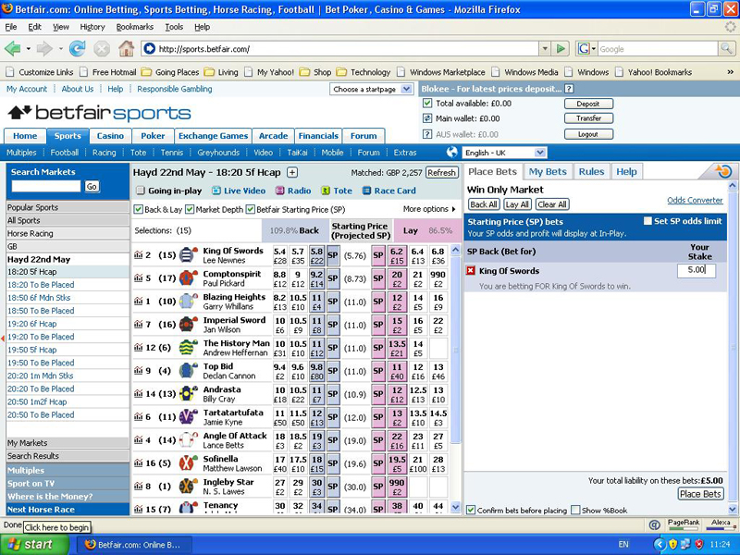
Backing at Betfair SP
Backing at Betfair Starting Price is betting that your selection will win, and the bet will be matched at the Betfair Starting Price at the start of the race.
- Locate the horse racing market of your choice.
- Confirm the Betfair Starting Price (SP) box is ticked.
- Select and click the blue SP square.
Your requested bet appears in the Place Bets tab on the right side of the screen.

- Enter the stake you want to place on the bet.
- Click the Place Bets button at the bottom of the screen.
Congratulations! You have submitted your Betfair SP bet!

Laying at Betfair Starting Price
Betting that your selection will not win is known as laying at Betfair Starting. At the start of the race the bet will be matched at the Betfair Starting Price. All Starting Price bets on each selection are matched at the same price.
- Locate the horse racing market of your choice.
2. Confirm the Betfair Starting Price (SP) box is ticked.
3. Click the pink SP square to make your selection.
Note: The bet will appear in the Place Bets tab.
- Enter the maximum amount you want to have on the race.
Note: This is different than how normal lay bets are placed on Betfair. With SP lay bets, you’re entering the maximum amount you’re willing to lose.
- Click the Place Bets button.
Congratulations! You’ll see the Betfair SP of each selection at the start of the race.

Setting starting price limits
When a person takes SP, they don’t know what price they’ll get. This makes it difficult to know if they’re getting value or not. So how can a punter find this useful?
On Betfair there is the option to fix a maximum price a bettor wants back at or a maximum price they want to lay at when placing a bet.
Setting SP Limits:
- Follow the steps to place a regular SP bet until you’re asked for your stake.

- Tick the SP odds limit box on the Place Bets tab.

- Enter the minimum price you’re willing to accept as SP.
Note: If laying at SP, set the maximum price you’re willing to lay at.
- Enter the stake you want to bet if you’re backing or the maximum liability if you’re laying.

- Click Place Bets.
- You’ll be able to change the price you’re willing to back to a lower amount in the Bet Manager, but you will not be able to make it higher.
- You’ll be able to change the lay at SP bets to higher but not lower.

Chapter 9

Poker, Games, and Casino
Casino and poker games provide great opportunities to make money online or a person can have great fun gambling online.

Games of Chance and Games of Skill – Know the Difference
One of the most important things in making any bet is, knowing if you are betting on a game of chance or of skill. It can be confusing but understanding allows you to choose the right style of approach and is the difference in winning or losing.
A simple rule to remember is, is the chance of something’s probable outcome changeable or is it fixed?

Playing online poker
Poke has many variants but is thought of to be a game of skill. There are many people who make a living from playing poker. To become familiar with playing online poker visit Betfair’s online poker where you’ll find tables you can play at for free. You’ll be able to use “pretend money” until you feel ready for betting at money tables.
Find information about playing poker online at www.betfairpoker.com or in Winning at Internet Poker For Dummies.

Online Casino – Chancing Your Luck
Blackjack, roulette, blackjack, and craps are all casino games. Betfair has over 40 casino games for you to play.

The Odds Are Against You
Playing an online casino game is strictly a game of chance. They’re governed by a fully audited Random Number Generator (RNG), which has no bias. The odds are set so the house is the slight favorite so over time the house wins. Even if you have perfected your strategies, over time you’re likely to lose.

Heading into the Zero Lounge
Visit the Betfair Zero Lounge at http://casino.betfair.com, if you want to play an online casino. Betfair took out the house edge when it redesigned the casino. This essentially means you’ll be playing a ‘fair casino’ where the house doesn’t have a better chance of winning over you.

Playing Exchange Games
Betfair’s exclusive exchange games – casino-style games based on a Random Number Generator (RNG), but use Betfair’s exchange technology to allow you to select the odds that you bet at. So you can ask for better odds than the ones offered. You can also back and lay and it allows Betfair customers to bet against each other as a game plays out. (Beware though, the odds change rapidly as the game occurs.)

Chapter 10

Finding Information
An important skill you need to develop is judging the relative merits of different types of information. You’ll be shown which sources of information to use and which to avoid. However, we will not provide you with a formula or system for winning and making money by betting.

Types of Information
When it comes to betting, the more information you can find out to use for what you’re betting on the better chance you have for your desired results or “final picture”.

Backing Your Opinion
First you’ll need to consider if your opinion on the bet you’re going to bet on is a valid one. Did you analyze the particular event carefully?
All bets come from having an opinion on an outcome. If you don’t own the opinion, then you may want to analyze it more thoroughly. You never know if a bet someone else gave you will pay off or not so it is best to think it over a little more.

Judging Information
Understanding the rationale behind information or an opinion is key to winning. If you rely on someone else’s information or opinion, you should ask yourself three important questions; Why, Who, and When.
- Why is this person imparting their knowledge to you? Do you have faith in this person’s integrity, why would this tip or opinion be passed on to you? Is this information unique to you or are thousands of other people benefiting from the same information being provided to you?
- Who is are you getting the information from? Is their opinion a valid one? What knowledge does this person have that is different than what you have? How accurate and complete is the information to the outcome of the event?
- When did this person receive this knowledge? Has it already affected the value or the price on offer?
A good habit to form is to always question any advice you’re given and then think it over and decide whether you trust the information and can use it comfortably.
Tipsters
This advice applies just as much to tipsters as it does to someone on the receiving end of the tip. If by chance you find a tipster you know and like then by all means take advantage of their advice. Just remember to question the opinion and analyze the information
Many times you’ll find a tipster is a celebrity, ex-player, or people involved in their specific sport. Often they know the participants of the sport and have great instinctive knowledge of their sport.

Chapter 11

Low-Risk Betting: Trading
The point of professional gambling is to emphasize any advantage the gambler has while minimizing the risk.
Some Betfair customers detest the thought of watching a football match or a race without knowing that they’ve already made a profit.

Buying Low, Selling High
In trading, a person lays a selection at lower odds and backs a selection at high odds (or conversely, back it at higher odds and lay a selection at low odds), and at the same time guarantee themselves a risk-free position. This approach is thought of as the buy-low, sell-high of betting.
- Backing – betting that something will happen.
- Laying – betting that something won’t happen.

Putting Theory into Practice
Golf is a good sport to illustrate how trading works in practice.
The British Open is being held at St. Andrews – a course that favors players who hit the ball a long way. Few players hit the ball harder and farther than Tiger Woods, so you back Tiger before the tournament starts for £100 at 5.0. This bet means that if Tiger lifts the title, you make a profit of £400 ((£100 x 5.0) – 100).
As expected, Tiger outdrives his competitors on every hole, and he’s three shots ahead of the field by the end of the second day. The odds on Betfair have now shortened and Tiger is available at 2.0.

There are two options at this point:
- Do nothing and cheer Tiger to the end of the game.
- Lay Tiger at the shorter odds to guarantee a profit, no matter what happens
The weather forecast at St Andrews doesn’t look good for the last two days of the tournament. Because you don’t feel Tiger will cope with the changing conditions very well, you lay him at the end of the second day for £250 at 2.0. This bet means that if Tiger lifts the title, you lost £250 to another Betfair customer ((£250 x 2.0) - £250).
But here’s the best part! You’ve already backed Tiger at higher odds than you’ve just laid, so you don’t care what happens – you win if he wins, and you win if he loses.
If Tiger wins, then you win £400 from your first bet and lose £250 from your second bet. That’s a net profit of £150.
If Tiger loses, you lose the £100 staked in your first bet and win the £250 staked in your second bet. That’s a net profit of £150.
This is a perfect example of risk-free position. Locking-in a profit or an all-green book, the second term refers to the fact that having completed the trade, you have a positive green number next to each selection in the market.

Making Life Easier
Crating risk-free positions isn’t always straightforward – especially if a person has a lot of bets in a market or if they’re trying to do things quickly. So unless it’s a person with some fantastic mathematical genius skills then adjust the Control Settings and let Betfair do the hard work.
- Get to the market you want to bet on.

- Click on More Options. (The Control screen appears.)

- Click the drop down box for Profit and Loss Display

- Tick the box entitled Display “What If” Figure.

- Click Save Changes.

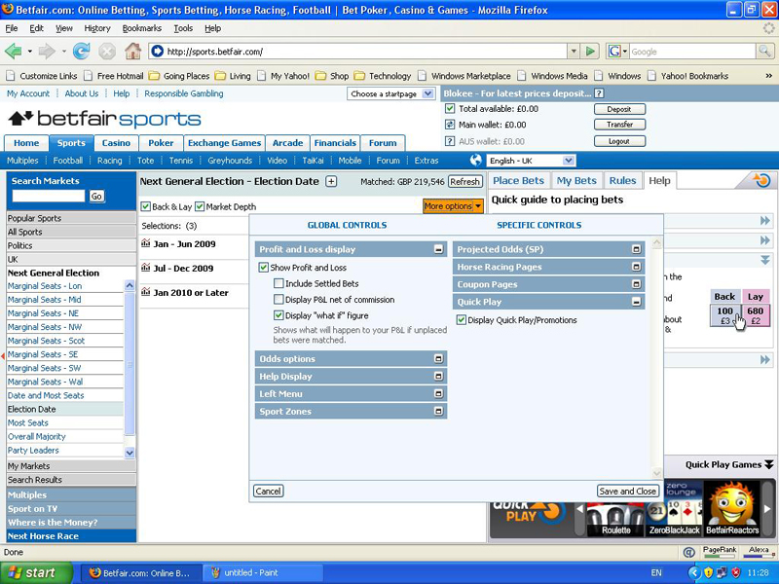
Control settings allow a person to quickly access the outcome of bets they’ve placed.
You can create the position you want by using this function to vary the odds or stake of your proposed bet.

Knowing When to Lock-In
There is no set rule on when to lock-in a profit or when to let your bet ride; it depends on the strategy of your betting. The concept of value is key to knowing when to lock-in.
Unfortunately, you can’t be sure of a competitor’s chances of winning an event at any given point. But what you can do is ask yourself these three questions:
- What chance does your selection have of winning the event?
- Are the odds on offer (whether backing or laying) better than the percentage chance of him winning?
- If the outcome doesn’t go your way, are you prepared to live by your decision?

The style of your trading and attitude to risk is what determines whether to trade out really depends on. Having this option allows you the ability to profit from being nearly right, even when you were wrong.

Following the Market

‘Buying Low, Selling High’ trading has a high level of risk. Trading opportunities appear but not always and if your opinion is wrong, the opportunity to trade out may never present itself.
There is not any kind of trading that is completely risk-free. If the market goes against your prediction, you’ll lose money. The value of your investments can go down too!

A Different Type of Trader
One type of trader tries to determine how to achieve a risk-free position. They don’t rely on how an even will turn out. This type of trader is similar to financial market traders than gamblers. Their focus is how a market will move before an event starts.
To do this they rely heavily on Betfair being a free market or a perfectly competitive market. The odds available to back and lay are set by all the thousands of individuals competing against each other. This also applies to buying and selling too.

Supply and Demand
In a perfect world, competitive market prices are determined according to supply and demand. People will lay on a particular selection if a lot of people are backing it to win so the odds for that selection will shorten, or get smaller. For the reverse, if a lot of people think a selection will lose the odds will drift, or get bigger.
The amount of money available for a customer of Betfair to back or lay on any selection appears under the odds of that selection.

The Professional’s Philosophy
A Betfair market trader’s philosophy is to make low-risk trades frequently and often. By using this approach, profits can add up quickly.
A technique sometimes used by traders is called spoofing. The idea is to trick others into changing the odds of a particular runner or team. When a person spoofs it means they are submitting a large bet to either back or lay a section.

Exploring More Market Strategies
The amount of money available on the back and lay sides of the market is what moves odds in a specific direction. At times traders use other concepts to determine what will happen with the odds.
These concepts are technical analyses and are something borrowed from the stock.
Technical analysis – looking for trends, patterns, peaks, bottoms, and other factors affecting a stock’s price.
Mean reversion - based on the mathematical premise that all prices eventually move back toward the mean or average. So, if a stock is underperforming, its price will move toward its average value when the market rebounds.
Financial markets can provide good analogies to help a person understand how the Betfair market works. Be careful to not take this too far since there are no guarantees that the techniques will work exactly the same every time.

Keeping One Eye on the Event
On Betfair rumors, counter-rumors, markets, and all types of events can affect the odds. Other factors, such as a TV presenter or popular newspaper writer can also cause markets to react. Always be aware of factors that can affect the Betfair market you’re betting in.

Chapter 12

Low-Risk Betting: Arbing
The emphasis in the last couple of chapters has been the ways Betfair resembles the financial markets. Arbitrage is another example of this similarity. Arbitrage is usually referred to as arbing on Betfair and a person doing this is called an arber.
In betting terms, guaranteeing you a risk-free position by backing a selection at high odds and at the same time laying it at lower odds elsewhere is called arbing.
This principle is the same as buying low and selling high, or vice versa. The only difference is that when arbing, you look to strike your bets simultaneously and in different markets, whereas with trading, you wait for an individual market to move in your favor before placing your two bets at different times.
Betfair is used for two distinct types of arbing:
- Between Betfair and another bookmaker
- Between different Betfair markets

Arbing between Betfair and another Bookmaker
Here is a real life example of how arbing works:
In the 2002 Soccer World Cup, England and Sweden were drawn in the same group. Patriotism seems to replace good sense when countries compete against each other in an event.
For this sports event, most English-based bookmakers offered England 10.0 odds to win the World Cup. Bookmakers showed no concern that these odds were much shorter than they should have been because they knew people would back the team regardless.
Betfair had the odds a bit higher at around 13.0, but even this showed English fans’ patriotism would prevail and no one would care the odds weren’t so good and would be more interested in adding financial support to their moral support.
On the other hand in Sweden, punters didn’t care about the English team so a Swedish bookmaker was offered the odds for England at 17.0.
This was used to massive advantage by many who switched-on arbers. Say for instance, an arber backs England with the Swedish bookmaker for £100 at 17.0 to win the competition. At the same time he lays England for £130 at 13.0 on Betfair.
If England won the tournament, the arber would win £1600 from his first bet ((£100 x 17.0) - £100). He would also lose £1560 from his second bet ((£130 x 13.0) - £130). The result is a net profit of £40.
Since England didn’t win the tournament the arber lost the £100 staked in the first bet, but won the £130 staked in the second bet, making a net profit of £30.

Arbing between Different Betfair Markets
Arbing between other bookmakers and Betfair is commonly found. Occasionally you can find opportunities to arb on Betfair between different markets.
A good example of this is in the game of soccer. Different types of markets are offered on Betfair with one being a Total Goals market. This is a market where you can bet on the number of goals will be scored, one or more, two or more, and so on. In the market called Over/Under 2.4 Goals bets are made on whether 2.5 goals or more would be made or less.

Some Final Words on Arbing
On Betfair arbing opportunities presented more regularly and in the betting market as a whole. Unfortunately, because a good thing gets around many more people are arbing now; as a result they’re becoming very sophisticated with some bettors using bots to find opportunities as they become available.
Betfair recognizes arbing as a low-risk betting and not a no-risk betting. There is no such thing as no-risk betting.

Chapter 13

Going Pro
Going professional is a decision that should not take lightly. It may seem glamorous to think of becoming a professional gambler, but the new job of going pro means there will be a great deal of uncertainty and you’ll have a lot more risk with it.

Working out what constitutes a living
Before you take the plunge to become a pro gambler consider these four questions:
- How much money do you want to earn from gambling in a year?
- Do you want to make the same salary you currently make?
- Do you want to make more than your current salary?
- Could you be happy with less than your current salary?
Now, work out the amount you’ll need to win in a:
- Week
- Month
From the experience you have of betting, does the amount sound reasonable to you?
Presently in the UK any income from a person’s winnings from gambling is not taxable. This is wonderful news for pro gamblers.

Assessing Your Qualities
Do you have the qualities it takes to be a professional gambler? Not everyone does and pro gamblers are a rare.
- Your coping skills need to be good to be able deal with the solitude of the job.
- You need to be able to cope with the uncertainty that comes with the territory.
- Your betting skills need to be consistently good enough to make profits.
Being a professional gambler is similar to being a professional sportsman and with it has the same pitfalls.
- No guarantees
- Up to You to Perform

The Most Common Attributes of Successful Professional Gamblers:
- Being Analytical
- Specializing
- Having Discipline
- Working Hard
- Taking the Plunge

Being Analytical
Winning gamblers are analytical about their gambling. Professional gamblers never say things like, “I think it’s about time so and so won a match so I’m going to match him.” Instead, professional gamblers meticulously analyze an event to great lengths conclude what the percentage chances are that something will happen. Very in depth methods are used to analyze betting.
- Spreadsheets – to organize and see trends.
- Databases – to organize, see trends and for tracking statistics.
- Automated Programs – to take advantage of opportunities at an instance as they become available.
Having all this information allows professionals to make valid decisions on whether or not to bet.

Specializing
Gamblers that bet on too many different things are often losing gamblers. The profit and loss account of a losing gambler often shows bets placed on everything from golf to horse racing to reality TV to financial markets and so on.
For a person to win consistently, they have to specialize. The degree of this depends largely on the personality and style of betting a person has. Regardless of what type, a person should rely on the limits of their knowledge and not stray from it.

Having Discipline
In any career path discipline is the key to success. This is more so important when gambling is the career because of the many opportunities to invest money in. Backing or laying something that doesn’t always fit in with your strategic plans is easy to do. A person needs to be careful to control their betting practices if they don’t want their bank to deplete.
People who lose money are often ill-disciplined. They place bets just for interest, make bets based on opinion rather than analysis, and chase losses they incur. Without the discipline to stick to your long-term strategy no matter what is happening, you’ll eventually lose.

Working Hard
Professional gamblers work standard work weeks at the least with most working a great deal more than the minimum. The busiest for a pro gambler are usually weekends and are usually the most lucrative for them. In other words, professional gamblers work long hours.
Pro betting can be a lonely job for a person and finding people with the same gambling interest to discuss your strategies with is a good idea. Two heads are usually better than one.
If you aren’t ready to put in the hours, the chances are that you won’t win in the long run.

Taking the Plunge
To make a living at betting you need to have the skills and strategies needed. A trial period of a week or so may help decide if this is the life for you by letting you experiment and refine your strategies.
Diary of a Pro Punter
A professional gambler using Betfair, along with other betting companies, agreed to let us shadow him for a week.
He specializes mostly in horse racing, but bets on a number of other events too. He utilizes a number of different profitable strategies –in-play betting, backing, laying, arbing and trading – so his activity gives a good idea of the range of ways you can try to make money on Betfair.
If you find any phrases that are new to you, see the Glossary, or look them up in the Index.

Day 1
Today should be a good one. There’s some great horse racing at Cheltenham, and they’re at the final stages of the World Darts championships – two televised events that always create a lot of activity on Betfair.
I spend the morning updating the speed ratings I keep for horse racing. I track the times that horses run for every race in the UK and Ireland and create a speed rating for each performance. I use this to quickly assess the relative ability of horses when analyzing a race to see if there are any value bets.
I then get stuck into analyzing that day’s racing. I tend to focus on a particular type of race at this time of year that are termed novice hurdles – it’s important to specialize in this way, because it’s the only way you can keep track of everything that’s going on.
A horse called Denman is very interesting in the first race at Cheltenham. He ran a fast time in his first race for an inexperienced horse, and I decide that he would represent a value back bet at any odds bigger than 4.0. But on checking the price, I see that he’s only available at 3.9. So it’s a no-bet. It’s difficult not to bet when you’ve don all the analysis – but it’s the key to long-term profits. If the horse isn’t value, then it’s not value – so leave it alone.
In the same race, there’s a horse called It’s A Dream. He’s joint favorite at around the 4.0 mark, but his form is nowhere near as good as Denman’s, and on my speed ratings, I reckon he should be more around the odds of 10.0. I’m fairly sure that the only reason he is such short odds is that his trainer and jockey are popular and their horses offer get over-hyped. But I’m more interested in the fact than hype, so I put in a lay of £100 at 3.9 and am pretty confident that it will get matched. It does.
I look at all the other races and analyze a few in detail but all the prices look about right to me and I don’t see any value bets. But that’s okay; the hard work always pays off in the long run.
A bit of lunch and then the first race is off. Denman absolutely slaughters the field and looks to be a pretty special horse in the making. I’d be lying if I said I wasn’t frustrated that I haven’t backed him, but you have to get over those feelings – it wasn’t a value bet at the time, so forget about it. Regretting not having a bet is a losing mentality in the long run. And anyway, It’s A Dream came nowhere so I won £100 on the race.
The big race of the day involves a horse called The Listener who has been impressive in his two runs to date this season. He’s trading at around the 1.85 mark. Whenever you have a short-priced favorite like this it’s always a good opportunity to trade, because the majority of the money in the market centers around the one horse – people either want to back it or lay it. So in the last 15 minutes before the off I start trading – laying at 1.83, backing at 1.85, and on and on. It’s not exciting, but if you can predict the way the market is moving, it’s a very easy way to make money for little risk. I manage to lock in a £363 profit, so no matter what happens in the race I’ll win.
I watch the rest of the day’s racing, but no opportunities to bet come up, except for a horse that doesn’t jump the first couple of fences to well in one of the later races. I try to put in a lay, but some other people beat me to it, so I cancel the bet and forget about it. The horse actually gets its jumping together and almost wins the face, so I feel glad that I missed the bet originally because it would have been a nervous few minutes!
The darts starts at 7 p.m., so I’ve got a couple of hours off. Drag myself to the gym. Staring at a computer screen all day isn’t all that great for the body and getting out and doing something is crucial – not that I’m very good at motivating myself to do it!
Back for the darts. I’ve been noticing throughout the tournament that another bookmaker has been slow to update its prices in the handicap match betting markets. Very often a player will win a set and yet it will take the bookmaker a good minute to adjust their price.
The same happens tonight and I'm able to back players with the fixed-odds firm and almost immediately lay the same player at a lower price on Betfair. You notice these arbing opportunities from time to time and have to take advantage – because it doesn’t take long for the fixed-odds guys to cotton on to what’s happening. I’ve had more accounts closed by these guys than I’ve had hot dinners!
But tonight it all goes well and I make £186.
£349 profit on the day.

Day 2
I wake early and see that Kicking King, the favorite for the Gold Cup, one of the big races of the year, has been ruled out for the season with an injury. A number of horses have been backed to win the race as a result of his absence and their prices have shortened. But people seem to have forgotten about a horse called L’Ami who has been performing well in the top races and isn’t that far behind the quality needed to win the race.
He’s 37.0 in Betfair’s ante-post market for the race so I back him for £200. I’m fairly sure that the market will come round to his chances in a few days and I’ll then be able to lay off my stake at lower odds and lock-in a profit. That’s the theory at least!
All that analysis of the Gold Cup means I’m behind on my work for the day. I update my speed ratings as quickly as possible and then start looking at the day’s racing. One horse interests me and is 14.0 on Betfair. I reckon it should be no bigger than 5.0 so I back it for £200. It falls at the first fence – ouch!
There are three short-odds favorites on the card today, so I spend a boring hour trading on the three of them. I backed one of them for £300 at 3.2 as the money on the lay side was starting to build up and it looked like the odds would shorten. But then his trainer was interviewed on TV and said that he didn’t rate the chances of the horse, and so the money disappeared and his odds began to drift. I get out of it the best I can by laying him back at 3.5 for £274. It’s a guaranteed £25 loss but better than £300!
It’s always better with trading to accept a small loss and move on. Waiting for a market to turn in your favor can be dangerous and lead to a much bigger loss. And anyway, I make £162 trading on the other two races.

Racing is over and my attentions turn to a cricket test match in Pakistan. I spent a lot of time looking at some statistics last year and it’s obvious that international test matches have become much more aggressive, meaning that matches are less likely to end in a draw these days. I lay the draw for £1,000 at 2.2 with the intention of backing it at 2.5 when the match goes in-play. All I need is a couple of wickets to fall early and that’ll easily happen.
More darts tonight, but others have obviously cottoned-on to this arbing trick. It’s become much more difficult to lay off my stake on Betfair and after a couple of hours I call it a day, with only £18 to show for my darts efforts.
£45 loss on the day.

Day 3

Wake up at 4 a.m. The test match in Pakistan starts at 4:30 a.m. and I need to be ready to get my back bet in on the draw as quickly as possible after it goes in-play. The match starts and I put up an unmatched back bet of £900 on the draw at odds of 2.5. This means that if it gets matched I’ll be guaranteed to win £150 if it’s a draw or win £100 if anything else happens.
I go back to bed at 4:45 a.m. and dream of batting collapses. Back at the computer at 9 a.m. and the bet is matched after five quick wickets fall early on.
Update my speed ratings, but there’s no racing today in the UK and nothing of interest in Ireland, so today is for catch up.
I’ve been working with a programmer to try to automate how I create my speed ratings, and he comes at lunchtime to discuss progress. Five hours on and although he’s confident, I’m not sure whether it’s going to work. I like the manual side to how I do things because it means that I can check and double check every figure to make sure it’s accurate. Not sure I can trust a computer, but then it would save me about three hours a day!
No money made or lost on the day and a 6 p.m. finish – and that’s on a day off!

Day 4

Up at 6 a.m. today. I’m working on a new snooker ratings system that I’ve been building.
It’s based on what’s known as an Elo ratings system, something used to rank serious chess players. The basis is that all professional snooker players start off with a virtual 1,000 points. Whenever they play each other, they put a number of these points at risk, say 50. Whoever wins takes all the points, meaning they now have 1,050. This goes on and on. It’s a way of assessing the relative ability of players and a good starting point for any snooker betting.
A couple of big tournaments are on the way and having watched the snooker markets on Betfair for a while I’m sure that there’s money to be made. But I’m pretty sure that I’ll only ‘paper-trade’ for the rest of this season to ensure that the ratings are up to scratch. I’ve dived into betting before too early and lost money. Just because you’ve put lots of time into developing a ratings system, doesn’t mean it will work!
I analyze the day’s racing. One horse stands out. I reckon he should be a 3.0 shot, but he’s currently available at 11.5. I put up a small back bet at 12.5 with the intention of topping this up over the course of the morning. By the start of racing I’ve managed to get £300 matched. I could have put all the money up at once, but that could have affected the market, pushing the price of the horse down, so it’s worth trickling it in when you have the time.
There’s an early race with an odds-on favorite that I trade for a bit and make £43 on the race.
Then the horse I’d backed in the morning runs and wins for a £3,450 profit. I’d be lying if I didn’t say I was feeling pretty pleased with myself, but it’s best to be as detached as possible. It was a value bet and it happened to win, but lots of other value bets lose. It’s the long-term profit you have to focus on.
The World Championship darts is over, but another world title (for a different governing body) starts in a few days. I’ll be keeping an eye out for arbing angles in the early rounds and then probably get involved in the final stages.
Lots of high profile soccer matches on tonight, but to be honest, I’ve never been able to make soccer pay. I know that lots of people can, but I’ve just never found an angle – despite investing hours in analysis and losing money trying out different approaches. That’s just the way it is really – you’re good at some things and bad at others and you just have to specialize. Soccer’s not for me, so it’s a 6:00 p.m. finish.
£3,493 profit on the day.

Day 5

Strange day today. Up at 7 a.m. and complete my speed ratings for the previous day’s racing and then analyse the afternoon’s fare.
Five bets today look like value. That’s a lot for one day. Can’t work out whether I’m just looking at them differently because I had a big win yesterday or whether they really are all value bets.
I decide to be cautious and decide on two of them that I’ll back. I’ll leave the other three alone. Best to be cautious.
The two I back lose and the other three win. That’s made me mad. I tied myself up in knots this morning second-guessing myself. In retrospect they were all value bets – sometimes there are five in one day – and I should have backed them all. Now I’ve lost £600 when I should have made another £800 or so.
I need to compose myself – it’s no good betting when you’re angry! I was planning to trade on a tennis match tonight but I call it a day at 4:30 p.m.
I feel tired as well. People think that being a professional gambler is easy. I don’t think they realize the hours of work I put in. maybe I need a holiday.
£600 loss on the day.

Day 6

Sleep in late today – which isn’t a good idea when there’s so much to get done before racing starts – but feel that I really needed it. I’m at my desk by 11a.m. and feel like I’m in a much better frame of mind now.
There are no value back bets today, but there’s an interesting novice chase with two joint favorites at round 2.5. The market seems to have forgotten the rest of the field and I’m not sure why. The two favorites are the odds they are only because they represent the two most powerful stables in the country – not because their form warrants it.
I lay them both – something I call a ‘double take-on’ – for £200 at combined odds of 1.25. I don’t think the two of them have a combined chance of 80 per cent of winning so I’m happy to lay them.
They both fall on the first circuit and a 90-0 shot wins the race: £200 won
No other bets for the day, but I’ll be keeping an eye on the rest of the racing from Sandown Park. They’re had a lot of rain there recently and the ground is very testing. And the final half-mile is all uphill. I think a number of horses that are leading at the bottom of the hill will trade at an artificially short price in-play and then tire before the end.
It’s hard to say exactly what I look for when betting in-play – which doesn’t sound very analytical! But over the years I’ve watched enough races to know when a horse has gone too fast early on. And just like humans, if they fun too fast too early, they won’t finish well.
That’s the thing about being analytical. It doesn’t have to be all spreadsheets and databases, as long as you’re taking a methodical approach and basing your assumptions on knowledge.
It’s not until the last race of the day that an opportunity arises. Two horses went off far too quick and one of them is left in the lead with 400 yards to run and looks like he’ll go on to win. But I’m convinced he’ll tire and get passed. I lay £555 at 1.1 (it’s quicker to type 555 than 500 and speed counts in-play!). The horse tires dramatically and ends up coming fifth.
That’s racing over for the day.

The horse I backed in the Gold Cup, L’Ami, has now shortened in price and I think about laying my stake off. But to be honest I still think he represents value and so I’m prepared to leave it for the time being. If it reaches anywhere near 14.0 I might change my mind.
£755 profit on the day.

Day 7

Racing is abandoned today due to frost and so it will be a quiet day. There’s a tennis tournament on in Australia that I’ll trade on in-play, but other than that I’ll be focusing on finishing my snooker model. It’s been four months in the making now and I’m excited to see how it works out.
The tennis is a disaster. Because it’s a tournament in Australia I’m convinced there must be people with at least a ten second advantage over me with the TV pictures I’m receiving. I lay a player for £2,000 at 1.91 thinking I’ll be able to almost immediately back him back at 1.92. Then suddenly the price collapses and he’s only available to back at 1.76. Something must have happened I haven’t seen yet.
I toy with taking the risk to see if I get matched at 1.92 eventually, but then sense prevails. I back him at 1.76 to guarantee a loss of around £170.
In the next point the other player falls and twists his ankle. A few people obviously got those pictures before me and that’s why the prices changed so quickly. I’m glad I got out of the position as it doesn’t take the guy long to finish his injured opponent off.
Enough of this – I can’t bet in-play with that kind of information disadvantage.
The cricket match I bet on earlier in the week has finished with a Pakistan win, so at least I bag £100 profit from that.
In the evening I toy with the idea of having a bet in the eviction market of a TV talent competition. A friend was telling me that in every show in the last three years, the evictee has been one of the first four people to sing. The favorite to be evicted is singing last and I think of laying him. But hang on; I don’t know enough about this stuff. I’ll leave it alone.
£70 loss on the day.

End-of-week- report

£3,882 up for the week.

That’s a very good week, quite a bit up on the average. Last year I made £88,000 in total, but you need to take £20,000 off that in costs (a programmer I use, satellite subscriptions, broadband, a new computer, and so on).
People always look at me suspiciously when I say I’m a professional gambler. I think they expect something altogether different – not a bespectacled geek who likes spreadsheets!
But analysis and hard work are the key to making money and I’m just not convinced that you can be profitable without it.
Pro betting is hard work. This week I’ve been sat in front of my computer for over 60 hours, I’ve only gone to the gym once, and I’ve hardly spoken to my wife. I’m earning more now than I did working in IT, but I’m not convinced I’m better off overall.
My best advice for someone thinking of going pro is to work at it while you’ve got a job to make sure that you can make it pay. Have trial days on the weekend and when you do start full-time; make sure you have something to fall back on if it doesn’t work out. Pro betting is not for everyone, so there’s no shame in admitting that to yourself. As much as I would like to be a brain surgeon, I just know it’s not going to happen.
And don’t be any under illusions. Gambling can be very solitary. If you enjoy the social side of work then you’ll have to work out a way of retaining that somehow.
Other than that, all I would say is good luck!

Chapter 14

Controlling Your Gambling
Gambling can be a lot of fun while playing a positive and constructive role in most gamblers’ lives. It can provide a distraction from life’s everyday worries and hopefully put some extra cash in your bank too.
However, for some gamblers, this harmless distraction can turn into something more serious. If it does, the effects can be devastating for a person. Relationship break-ups, psychological problems and financial difficulties are just a few of the common results.
Problem gambling and gambling addiction can have many of the same adverse devastating consequences as other addictions, much like alcoholism. The particular problem with gambling is the difficulty others have in spotting the addiction. People notice if someone’s always stoned or drunk – but how does a person tell if someone has just lost their next mortgage payment?
If you’re reading this chapter and thinking that none of this applies to you, that’s great. But even if it is the case, we recommend you read this chapter anyway, because much of what the problem gambler does is what the winning gambler doesn’t do. These are the things you need to avoid to win on Betfair.
In this chapter, we look at how to prevent gambling from ever becoming a problem, how to tell whether you may be struggling, and where you can turn for assistance.

Preventing a problem
Most Betfair customers, at one time or another, display characteristics associated with problem gambling.
This fact doesn’t mean that all Betfair customers have a gambling problem – far from it! Long-term profits, however, rely on gamblers being analytical and disciplined, and as humans, people occasionally fall short on both these counts.

At one time or another, most people have bet on an event just for interest. Very little thought goes into the bet, and although people occasionally win like this, most of the time they lose in the long-run.
Similarly, some people lose money on one bet and immediately look for another bet to recover the losses. Most people realize that this strategy is flawed and manage to refrain. Others place the bet and succeed in their aim. What’s certain is that although you’ll sometimes be successful in chasing (as this behaviour is known), at some point, losses become so large that nothing is left to chase them with.
Betfair has a number of tools to prevent you from replicating these types of mistakes.
We recommend that you set up some of the following limits, however confident you are that you’ll never stray from your strategy or common sense. This extra level of discipline doesn’t cost anything!
To place some parameters around your betting, do the following:
- Log into your Betfair account.
- Click “My Account” at the top of the screen.
- Click “My Profile” on the left side.
- Click on “Responsible Gambling”.
- Click Edit.
Here you can manage three aspect of your account to assist with problem. Select each one to change the settings.
  - Limit Currency Deposits.
You can set a maximum amount to deposit into your account in a specific time period. For example, you may decide that you don’t want to deposit more than £150 a month into your Betfair account. This limit prevents you from chasing losses, because you can’t deposit the money required to recover what you’ve just lost.
  - Limit Losses
You can set a maximum amount of money to risk in a time period. Once this amount has been lost, the system stops you from placing any more bets.
  - Exclude Me From the Site.
If things get vey bad, this option allows you to close your account for a period of time.
- Click Save

If you feel that you’re having problems managing your betting, the Betfair staff is trained by Gamcare, an organisation in the UK that helps problem gamblers. They help advise you of different ways to manage your account and point you in the direction for further help. You can contact them on 0844 871 0000, or you can call Gamcare direct on 0845 6000 133.
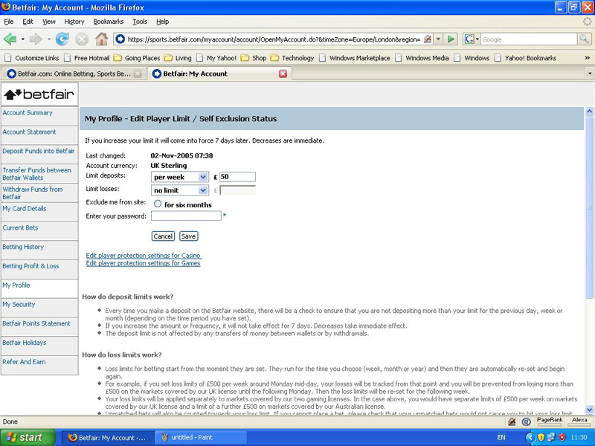

Recognise You Have a Problem
Recognising you may have a gambling problem is not easy to accomplish. It is even harder to finally reach the stage where you fully admit you have a problem and seek help.
If you’re starting to notice your gambling is getting out of control and question whether you’re able to manage it, ask yourself the following questions. If you answer ‘yes’ to a lot of the questions, consider seeing out help.
- Is your work life, home life, or relationships in general being negatively affected by gambling?
- When you’re gambling or after you’ve gambled, do you ever feel guilt or remorse?
- Whether you win or lose, do you still have a strong urge to continue to gamble?
- Has your financial position been adversely affected by gambling?
- Do you find yourself feeling not your usual self, down, or depressed?
If you answer ‘yes’ to one of these questions it doesn’t mean you’re addicted to gambling. If you’re wondering if you may have a problem, ask yourself these questions once in a while as a quick check on your gambling activity.

Getting Help
Several people have a gambling problem and seek out help. You can ask any who have successfully stopped and they all tell you the same thing – stopping made their lives much happier.
Most of the time anyone admitting they struggle with something can put a dent in their pride, but the results can be very cathartic. You no longer have to live a double life trying to hide all your feelings and live in a world of semi-secrecy. Instead, you can find a support system to talk about how you’re feeling and be honest with people about your problem.
Family and friends are an important source of help for people with gambling addictions. In addition to strong family and friend support there are many professional organizations around the world who can offer support and counseling as well.
Organizations vary by country. Within the UK, Gamblers Anonymous (call 020 7384 3040 or visit www.gamblersanonymous.org.uk) both work with people with gambling problems.
If you’re outside the UK, enter ‘gambling addiction’ on an internet search engine to find a local organization that can help. If this fails, call Betfair’s Helpdesk for assistance (0844 871 0000).
A recovering gambler, who has control of his gambling problem, has three things to tell anyone struggling with gambling addiction:
- You’re not alone
- You can find a way out
- You can find people to help

Chapter 15

Ten Common Mistakes to Avoid
On Betfair the topic of mishaps and mistakes seems to always come up. There are so many stories of people losing money when it was avoidable.
Surprisingly enough beginners rarely make these avoidable mistakes. Instead, those who feel a little bit on the comfortable side and have been using Betfair for some time. Perhaps it’s due to a misplaced sense of confidence or perhaps, people are trying to do things a little too quickly.
The reason is irrelevant and the goal is to make sure the same mistakes aren’t made by you.

Not Reading the Rules
Before you place any bet, make sure you look at the Rules tab on the right-hand side of the market. What constitutes a white Christmas? What happens in the even t of a dead heat? Will unmatched bets be cancelled when an event goes in-play?
You need to be able to answer this type of question to bet effectively. And if you’re ever in doubt, don’t bet.

Laying the Wrong Odds
Tom’s most embarrassing and, more importantly, most expensive mistake on Betfair was the time he intended to lay a horse at 1.35 but unfortunately forgot the all-important decimal point.
The result was that he asked to lay a horse at 135! Luckily, enough money was queued up to back the horse and the bet was matched at average odds of around 3.5. Nonetheless, a costly mistake – especially because the horse won easily.

Laying When You Mean to Back
At times, Betfair is all about split second decisions and fast fingers. A useful function on Betfair is the Control Settings, which you can find by clicking More Options at the top left-hand corner of any market. Under the Odds Options tab on this screen, you can change the colour of the Lay column to make it clearly distinguishable from the Back side of the market. Alex sets up his account so it always displays the Lay side as a luminous yellow and this seems to have eliminated mistakes caused by mixing up the two columns.
No one knows how many people make this mistake and how often, but every day, when reviewing odds movements over time for a particular selection, you can see spikes where odds suddenly get matched at way above the going market rate. Although a bettor might have a particularly strong opinion, the more likely reason is that someone is mistakenly laying rather than backing.
So take your time!

Taking the Available Odds in Quiet Markets
When markets first open on Betfair, some time can pass before enough people become involved to make these markets liquid (meaning there’s lots of activity in them). Therefore, you often get people asking for unrealistic odds, and large spreads can appear between the best odds available to back and the best odds available to lay.
Even if you’re in a hurry, don’t be tempted to simply accept the best odds on offer. If you do, in the long run you’re consistently likely to accept worse odds than you should.
If you want to back a selection that’s currently available at 2.0 to back and 3.0 to lay, you’re much better off requesting a back of, say, 2.6 and waiting to see if it gets matched. If it doesn’t get matched, you can always reduce the odds you’re asking for at a later date.
This approach requires more effort, but in the long run your Betfair activities are more profitable.

Betting “Just for Interest”
Winning on Betfair requires the discipline to bet only when you’ve done the work and know that the odds you’re backing or laying represent good value.

Chasing Your Losses
When you lose bets don’t chase them trying to win it back. Instead, if you have a plan, stick to it. You can only achieve long-term profits by having a consistent and disciplined approach.

Assuming Something Goes In-Play
Some betting strategies depend on taking a position like backing or laying a chosen runner or team before an event starts and trading out of that position when betting goes in-play.
Although lots of events are covered in-play by Betfair, this is not always the case. So make sure you check the Rules tab on the right-hand side of the market before embarking on this kind of strategy.

Leaving Unmatched Bets Open
A good strategy can be to request bigger odds than are currently available, but you need to choose the markets carefully.
Ask yourself whether something could happen in a market that would see your bet being quickly matched with little chance of it winning.
Always think about what you’re betting on. You need to decide when to leave unmatched bets on Betfair, and in what markets to do so.

Betting on Something On-Play That Isn’t Live
In the Rules section for any in-play market, Betfair always display the phrase, ‘Transmissions described as live by some broadcasters may actually be delayed and that all in-play matches are not necessarily televised’.
Always be aware that someone could have a few seconds advantage over you in the event you’re watching on TV. For example, someone watching the US Masters from the 18th hole at Augusta knows that a golfer has sunk a putt before you do. Nothing is sinister about this, but the fact is that a few seconds can easily pass while the TV pictures you’re watching go through production and bounce off different satellites.
Betfair puts a delay on placing bets in most in-play markets to protect customers, but still be aware about how fast your information might be.

Spending Too Much Time on Betfair
Betting on Betfair is fun, exciting, and provides intellectual stimulation – and if you do things right, you can make money. But be aware of how much time you spend betting.
Long-term profits come from selective betting. By definition, if you’re spending too long on Betfair, you probably aren’t being selective enough.
It’s obviously impossible to define how long is too long because it depends what kind of betting you’re doing. But as a guide, plan how much time you’re likely to be on Betfair for each day. If you’re frequently spending longer than this, or betting on things that you hadn’t thought you’d be betting on at the start of the day, then it’s time to log off.
And if you find it difficult to log off, it might be worth checking out chapter 14.

Chapter 16

Ten Top Tips
Betting is something you typically do on your own, and so you don’t usually have people around to ask for advice. We both agreed that we had improved our betting and had become much better informed punters after we started working at Betfair and were surrounded by lots of other bettors.
For this list of top tips, we asked a thousand or so Betfair customers what helped them to win on Betfair. This chapter outlines their most popular pieces of advice.

Have a Betting Bank
Put aside a designated amount of money for betting. Ensure that this amount is money that you can afford to lose if things go wrong. Ask yourself whether you have a maximum sum you’re prepared to lose in a month or in a year. Whatever you decide, stick to it.
This advice may sound overly sensible and boring, but is vital if you’re to make long-term profits on Betfair. If the money you allocate for betting is the same money you intend to use for mortgage payments or school fees, you’re adding a whole new sense of pressure to the situation.
Undue pressure adversely affects the decision-making processes. Successful bettors are able to walk away after their tenth losing bet in a row because they know that their strategy will prove profitable in the long run. If you need a winning bet to pay the rent, you’re likely to start doing things that aren’t part of your long-term strategy. And that usually means you end up losing more money.
One professional gambler has an interesting outlook on this philosophy: ‘I forget about the money completely. I do what I know will prove right in the long run and just use my betting bank as a way of keeping score. At the end of the year, if the bank is bigger than it was at the start, then I know that I was doing things right. If it isn’t, then I know that I need to improve.’
We recommend having regular reviews of your betting bank (say every three months) and deciding in advance what your approach to profits will be. If you’re in profit, will you take the profit out and use it for something else? Or will you leave it in and look to increase your stakes accordingly? Both approaches have merits and your decision needs to be based largely on your attitude to risk.
Although remaining detached from the money can be difficult, keeping a clear mind when betting ensures that the decisions you make aren’t clouded by an overpowering need to win.

Assess Your Position With Control Settings
Unless you’re a walking calculator, quickly assessing your position in the market after making a bet can sometimes be difficult. Luckily, Betfair can do this calculation for you.
To assess your position quickly:
- Log in and go to the market you want to bet on.

- Click the link “More Options”.
- Check the boxes for the options you want.

- Click Save

This will set up a market profile that will make your betting a lot easier.

Here are the various options you can consider when working with the market settings:

Under Odds Options
- Change the colours of the Back and Lay columns.
A more contrasting market view is a great way to prevent you from accidentally laying something you mean to back. (Refer to Chapter 5 for more on backing and laying.)
- Odds Alerts
You can select the odds to flash to alert you when they change.

Under Profit and Loss Display
- Include settled bets in profit and loss (P&L) figures.
(Refer to Chapter 3 for more on P&L.) In certain markets, such as the World Cup Winners marker, after a country is eliminated, bets are settled on that country. Select this option if you want your overall P&L figures for that market to include bets that have already been settled.
- Show P*L figures net of commission.
This option ensures that your current commission rate is included in any calculations.
- Show a separate future position.
If you select this option every time you’re about to make a bet, the screen shows what your position would be if you were to go through with the bet.

Try My Markets
The ability to bet on lots of different events, and choose from a multitude of different markets for each event, is one of Betfair’s great advantages. This level of choice ensures that every style of betting is accommodated.
However, this large number of markets means that navigating to the things you’re actually interested in can often take some time.
Fortunately, the My Markets link (on the left-hand side of the screen) allows you to select which markets you want to appear in the menu when you’re logged in.

Open Multiple Betfair Screens
If you’re betting on more than one market at the same time, open as many Internet screens as you want and log into Betfair on each one. You can quickly navigate between the different screens instead of having to find each market in the menu.

Invest in the Best Equipment
If you’re betting a lot – and particularly if you’ve decided to go pro – ensuring that you’re giving yourself the best possibility of winning is vital. Since Betfair has been running, many people have been designing trading applications and new software that interacts with the Betfair betting engine.
If you’re not betting via a broadband connection and you don’t have live information, you’re in danger of being pipped to the post by someone who does
Betfair has invested heavily in providing an Application Programmers Interface (API). An API is another access point into the Betfair betting engine. It allows third party software developers to design other interfaces, so you can bet with different programs other than the Betfair site.
This means that you can buy clever trading systems that are integrated with form products – such as Timeform-i for example – that can make your decision-making and betting more efficient. You can find out about these systems and programs at http://bdp.betfair.com which showcases the best software on the market. If you’re relying on the speed of getting your bets on, the right equipment could be invaluable.

Use Keyboard Shortcuts
Keyboard shortcuts can speed things up when you’re trying to place a bet quickly.
Use the up and down cursor keys to adjust the odds you’re betting at. You can also use the Ender key to submit your bets.

Get in the Zone
Betfair offers a number of different spots-specific ‘zones’. These take the latest markets from a particular sport and pool them on one page, which enables you to quickly look at the different betting options available on a particular sport, match, or tournament. Some of these zones can lead you to information sources such as results and form guides.
Find the zones from the navigation bar on the Sports homepage. Links under Sports:
- Multiples
- Horse Racing
- Cricket
- Others

Check Your Bet
Every time you submit a bet, Betfair takes you to a confirmation screen. When you first start betting on Betfair, check through the bet details on this screen to ensure that you’re doing what you want to do.
As you become more confident, you can uncheck the Verify Bets option at the bottom of the Place Bets panel. But we don’t advise making this change until you feel that you have a full grasp of what you’re doing. Speed is important in some instances, but placing the bet you want is important all the time (see ‘Beware Fat Fingered Typing’ a little later on).

Experiment With the Percentage Book Function
The bottom right corner of the Place Bets panel contains a box called ‘% Book’. Simply select this option to display the combined percentage odds at which you’re backing or laying.
This function is very useful when you’re trying to work out the combined percentage chance of all your bets. For a full explanation of having more than one bet in a market and what the percentages mean, refer to Chapter 6.

Beware Fat Fingered Typing
In the world of financial markets is a syndrome called ‘fat fingered typing’. If manifests itself when a financial trader types incorrect details into the computer and executes a trade that he or she didn’t intend. These mistakes happen on a daily basis, but in some cases the results are catastrophic.
In December 2005, a trader at Mizuho Securities wanted to sell one share in a new telecoms company at 600,000 yen. Unfortunately, he actually sold 600,000 shares at one yen each!
The mistake cost the company around 30 billion yen and sent panic through the Japanese financial markets, with the Nikkei 225 falling 2 per cent on the day. And the trader who was guilty of the error is probably not all that popular with his colleagues. The Christmas party, scheduled for the day after the mistaken trade, and the payment of a staff Christmas bonus were both cancelled.
Although yet to be seen on Betfair to the same costly extent, we’re certain that similar mistakes are being made by customers on a daily basis.
A customer who uses Betfair extensively on a day-to-day basis said, ‘I spend a lot of time monitoring the markets through the type of betting I do and it’s clear that from time to time, people make the most almighty errors. You’ll suddenly see the odds plummet to far shorter than they should be or skyrocket out to far longer. It’s clearly someone who has backed when they meant to lay, or typed the wrong odds or stake.’

Chapter 17

Ten Sporting Information Sources
Throughout this book we talk about different ways of finding value, using data, and making the most informed decisions you can to be a successful bettor. Here are ten of our most used and most useful information sources.

The Racing Post
If you bet on horse racing in the UK, you’re probably a subscriber to – or at least a regular reader of – the Racing Post. The paper is available daily from newsagents and is full of opinion and comment – some brilliant and insightful and some less so. The paper itself is jam-packed with tipsters – such as the wildly popular Pricewise, and the exchange specific Trading Post columns.
The real value that you find from the Racing Post for assessing your betting selections is in the form database on their website at www.racingpost.co.uk. Here you can find full histories of every racehorse in the UK, along with information about each of its runs, its trainer, jockeys, and some notable comment. The website is the best place to start if you’re looking to examine a race.

Timeform
Timeform is the world’s leading database and publisher of form with the best and most reliable data going. Timeform takes a bit of time to learn how best to use it, but it’s worth the effort if you’re serious about making money on horse racing. You can buy the famous blue Timeform racecard with information on the day’s action at IL and Irish racecourses, or visit www.timeform.com.
In conjunction with Betfair, Timeform have recently developed Timeform-i, probably the most advanced horse racing form and betting product ever offered. Timeform-i is integrated with the Betfair exchange and includes pretty much everything you’ll ever need to successfully bet on horses. Take a look at www.timeform-i.com to find out more.
Betting.betfair.com and the Betfair Forum
Increasingly the world of the Internet is dominated by interactive content and blogs – online logs of information from individuals on whatever happens to be of interest to them. Identifying useful sporting and betting blogs can be very valuable for discovering important and relevant advice.
Betting.betfair.com (http://betting.betfair.com) and the Betfair forum (www.betfair.com) are sites where you can find this type of live information and opinion. Someone once said to Alex at a race meeting ‘If you can’t find something out on the Betfair Forum, it’s not worth knowing’.
Be selective about who you listen to. For every person out there trying to help, there are plenty trying to take advantage. So tread cautiously.

Cricinfo
Cricinfo is without a doubt the best place to find statistics and information about cricket. The website, at www.cricinfo.com, offers comprehensive information from around the world of cricket, along with up-to-the-minute news and statistics. Cricinfo may take you a little while to get used to, but it’s worth spending the time to decipher the right statistics.

The Met Office
Keeping an eye on the Met Office’s website at www.metoffice.gov.uk is an excellent tip from a professional gambler friend of ours. He bets on horse racing mainly, but it’s just as important to have a good idea of the weather for pretty much any sport played outside.
Think how helpful it would be to know that the forecast for the first day of the Open Golf Championship is for a still morning, followed by gales in the afternoon!

The BBC
Having one consistent and reliable source of information on multiple sports is always going to be difficult. For one generalist sports site, the BBC is probably the best. The BBC have a greater resource than most news organisations, and they tend to be the quickest to post up-to-the-minute sports information. Visit www.bbc.co.uk or www.bbc.co.uk/mobile if you’re on the move.

The Betfair Developers Program
For the latest tools of the betting trade, the Betfair Developers Program website at http://bdp.betfair.com is the place to find software packages and trading tools that can really help with your day-to-day betting. You can find a forum for people who want to discuss the technology and a support centre where you can get more help with identifying the right equipment. If you’re going to take trading seriously, this is a good place to start!
If you like checking out widgets and gadgets, http://labs.betfair.com is where the Betfair boffins demonstrate their latest brainwaves. The gadgets are mainly unsupported ‘Beta’ products, but they’re worth checking out to see what’s happening and if a freebie’s going!
Go to the Extras tab on Betfair (http://extras.betfair.com), to find information about how to download Betfair Mobile, how to get fixture information, how to refer people to Betfair and earn money in the process, and a load more information about how to get the most out of your Betfair account.

Other Bookmakers via Oddschecker
We talk a lot about betting on Betfair (well, Winning on Betfair for Dummies would be a silly name for a book if we didn’t), but you mustn’t forget that to be successful you need to be aware of what’s happening in the whole market. That means keeping tabs on other bookmakers and their prices. You can start to recognize patterns – perhaps that one selection is shortening – and that information can be valuable in assessing whether you’re getting the right price or not.
Luckily for us, different sites keep tabs on the prices of dozens of different bookmakers on a range of sports in real-time. Probably the best for this is Oddschecker (www.oddschecker.com), which is reliable and easy to use, but if you prefer, just search for Odds Comparison in any Internet search engine.

LiveScore
If you’re a shrewd football punter, you might find yourself betting on other leagues around the world. And nothing’s worse than sitting with Teletext slowly refreshing when you need that last-minute goal to win your bet.
LiveScore is the most reliable website we’ve found, and it covers hundreds of games from dozens of leagues around the world. Check out www.livescore.com.

Betfair Radio
If you find yourself motoring back from a race meeting wondering how your horse is getting on in the last race of the day, Betfair Radio could be the answer. Betfair Radio was launched in 2007, and has become a key information source.
On Betfair Radio you can hear live commentary on UK and Irish racing throughout the day, as well as news and commentary from the world of sport, poker, and entertainment (when it’s being bet on!). The radio station is run by punters, and you’ll find the best from the Betfair Forum, discussed open and honestly and in impartial from the team.
You can access Betfair Radio through http://radio.betfair.com, or listen to races on the phone by dialing 08712 444 350 (calls cost 10p per minute).

Chapter 18

Ten (or so) Most Amazing Markets
A week rarely goes by without a Betfair market throwing up a surprising story – a ‘certainty’ that gets beaten, a huge odds turnaround for a particular selection, or a surprise win for an outsider.
The eclectic nature of Betfair makes selecting a list of the most amazing markets hugely subjective. However, in this chapter we provide some favourite stories (more than ten because we just couldn’t narrow them down!). These markets are illuminating and confirm that sport and life are unpredictable, the seemingly impossible can happen, and you can always expect the unexpected – especially when you’re betting…

Cheltenham Gold Cup, Ante-post Market, March 2005
Kicking King had long been prominent in the ante-post betting for jump racing’s blue riband. However, after his trainer, Tom Taaffe, revealed that the horse had returned a ‘dirty scope’ (meaning that he had a respiratory infection) and would be unlikely to run in the Fold Cup, his odds drifted markedly – out to the maximum of 1,000.
The horse staged a remarkable recover, lined-up on the day of the race as a warm favourite and proceeded to win the race easily.
In perhaps the most remarkable ante-post market story, one punter won nearly £25,000 for a £25 bet, and another won nearly £10,000 for £10.

Inter Milan versus Sampdoria, Match Odds Market, January 2005
Usually if a soccer team is 2-0 down in the 88th minute of a match, the result seems pretty inevitable. Indeed, when Inter Milan were in this position, they were traded at the maximum Betfair odds of 1,000.
However, two minutes and three goals later, Inter Milan were celebrating a famous victory while one Betfair customer nursed severe bruises (and a five-figure loss) after laying what he thought to be an impossible result.
Final Ashes Test, Richie’s Last Words Market, September 2005
The stage was set for a pulsating last day of play in the final test of the Ashes, with England needing a draw to regain the trophy. The day was also notable for marking the retirement from British broadcasting of Richie Benaud, cricketing and commenting legend.
On a Betfair market that asked customers to predict Richie’s last words in the commentary box, ‘Thank you’, ‘Goodbye’, and ‘It’s been a privilege’ were all backed heavily.
But, always the consummate professional, Richie simply handed over to his two colleagues, Mark Nicholas and Tony Greig, and so ‘name of anyone on the commentary team’ emerged as the winner – traded at 24.0.

Next Newcastle Manager Market, September 2004
Next manager markets are notoriously volatile – with rumour and counter-rumour fuelling dramatic market swings. Perhaps the most volatile was the market to predict the next manager of Newcastle United at the start of the 2004/05 English Premiership soccer season.
Eventual winner, Graeme Souness, was matched at the maximum Betfair odds of 1,000, but maybe more remarkable were the number of different names supported as favourite over the course of the market.
Terry Venables traded at 1.45, Alan Shearer at 2.8, David O’Leary at 2.8, Steve Bruce at 3.75, Gordan Strachan at 4.0, and Steve McClaren at 4.0. Therefore, seven different individuals were favourite to get the job at one point or another.

Breeders’ Cup Turf, Win Market, October 2003
One of the most exciting horse races in living memory led to one of the most amazing in-play markets in Betfair history.
The European horse High Chaparral fought out a close finish with america’s Johar, with both horses appearing to cross the line simultaneously.
Betfair’s in-play market was left open to allow people to bet on the result of the photo finish – something that’s usually confirmed in no more than a minute or so.
But this finish was very close. Because the race was one of the most important of the year, the judge wanted to make sure that he got it right, and it was over 15 minutes before he declared that the result was a dead heat!
During that time, over £250,000 was matched on the result of the photo finish.

Benson & Hedges Masters Snooker, White versus Ebdon, February 2003
When Peter Ebdon took a 5-1 lead in his match against Jimmy White, plenty of people thought the result was in the bag. Over £14,000 was matched on Ebdon at 1.01 (to win £140!).
Unfortunately, those Betfair customers who thought the fat lady was already in full flight discovered that she was just warming up. Jimmy White staged a remarkable recovery to win 6-5.

Champions League Final, Liverpool versus AC Milan, May 2005
At the start of the final, many Betfair customers thought that a draw in 90 minutes was a distinct possibility, and this result was backed at 3.2. However, few could have predicted the circumstances in which the draw came about.
Three AC Milan goals in the first half saw the draw trade out to an odds of 100. But three second half goals from Liverpool secured the draw for a few lucky customers.
In the Champions League outright market, Liverpool traded at a high of 250 to win the competition before going on to claim the title 3-2 on penalties.

Ascot, Historic Place, February 2004
Some Betfair occurrences defy explanation – none more so than the in-play betting on the horse Historic Place after he had already passed the post first at Ascot.
The in-play market had been reopened after a stewards’ enquiry was called in to investigate whether Historic Place had caused interference to the runner-up, Senor Sedona, in the final stages of the race.
On Betfair customer must have had a strong opinion that the stewards were going to disqualify Historic Place because he laid £3 at 1,000 and £15 at 550 on the horse.
After some deliberation by the stewards, the result was left unchanged, costing the luckless layer over £10,000.
Debate still surrounds why the customer struck the bet. Betfair spokesperson, Tony Calvin, said at the time, ‘It’s a remarkable figure to be laid. Someone either had a strong opinion or it was a bet made in error.’

U17 World Championship Soccer, Cameroon versus Portugal, Match Odds Market, August 2003
One Betfair customer celebrated an unlikely result after backing the draw at 550 when Cameroon were 5-0 down against opponents Portugal.
Cameroon scored five goals – the last in the 92nd minute – to gain a bizarre draw.

Greyhound Derby, Heat 21, May 2004
Although, greyhound racing is a popular sport with Betfair customers, non-televised races rarely attract much interest.
So when someone requested a £1 million bet in the market on the greyhound Escholido, who was running in a heat of the Greyhound Derby at Wimbledon, people were amazed.
After all, a group of high-staking bettors may sometimes trade £1 million on popular horses in the very biggest races, but rarely a single individual. And in greyhound racing, this size of bet is unheard of. Famed high-stakes punter Harry Findlay owned the greyhound, but he refused to respond to speculation that he requested the bet.
Ultimately, just a few layers were prepared to take on a bet with that amount of confidence and only (!) £192,000 was matched on Escholido – who went on to win the race easily.

Next Liberian President Market, November 2005
Betfair’s political markets create a lot of interest – from bettors and political commentators alike. In fact, in most circles, these markets are now seen as a much more reliable guide than any opinion poll as to the likely result of an election or important vote.
In the Australian Federal Election of 2004, pollsters were calling the race neck and neck. And yet on Betfair, the Coalition Party was the overwhelming favourite. The Coalition went on to win in a landslide. A similar story occurred a month later in the United States, where pollsters couldn’t separate the Democrats and Republicans. Betfair customers could though, having George Bush as the overriding favourite to win – which he did, of course.
But sometimes, the markets on Betfair get things very wrong.
When Betfair opened a market on who would be the next Liberian President, it wasn’t a market they expected to attract much interest! But as ex-Chelsea and AC Milan soccer star George Weah was running for the office, they soon began to be proved wrong.
The market created huge interest, particularly as many Betfair customers thought that Weah’s fame made him a certainty for the government. At one point during campaigning, Weah was backed at the minimum of 1.01 to become the next president.
However, the backers were wide of the mark because the largely unconsidered Ellen ‘Iron Lady’ Johnson-Sirleaf went on to win with a margin of around 20 per cent of the vote to become Africa’s first elected female leader.

Australia versus Zimbabwe Match Odds, Twenty20 World Cup October 2007
Twenty20 cricket is liable to throw up surprises and this rain-affected match was no disappointment. The swings that a wicket or a six can bring in the short format of the game make it as exciting to bet on as to play.
In a pulsating match of quick wickets, quick runs, and massive downpours, Zimbabwe got home on the penultimate ball, despite Australia having been matched at the minimum price of 1.01 for nearly £200,000. The match is a great demonstration of how having all the information at your disposal (such as a good weather report!) can be profitable.

Chapter 19

Ten Betfair firsts
Betfair opened for business on Friday 9 June 2000, and was initially run from a small office in Russell Square in London.
For the first time, instead of having odds dictated to them by a bookmaker, customers were able to set their own odds and see if anyone disagreed with them.
Fearing extra competition in their market, traditional bookmakers reacted by calling Betfair pariahs, criminals, and vagabonds
This disdain for the new kid on the block wasn’t helped by Betfair’s first marketing slogan, ‘Revolutionising Betting’ – something that the established bookmaking industry wasn’t exactly keen on!
A lot has happened since then; Betfair is now accepted as an established part of the bookmaking industry, with over 1,000,000 registered customers, 250,000 of whom are active in any one month. Customers in 85 countries use the site, and 14 different languages are available. The Betfair database deals with over 5,000,000 transactions a day, and at peak times matches more than 12,000 bets a minute.
And many ‘firsts’ have happened along the way…

First Market
Betfair’s first market was the Epsom Oaks, won by Love Divine on Friday 9 June 2000.
Twenty-two participants took part in that market – most of them sitting together in a small office at Betfair HQ. The amount matched on the market was £1,476, with 63 bets made.
On the 2005 Epsom Oaks, over 12,000 customers made 38,000 bets, matching over £2.7 million!

First £1 Million Market
In April 2002, Tiger Woods won his second successive US Masters golf tournament, beating Retief Goosen by three shots joining Jack Nicklaus and Nick Faldo as the only golfers to record back to back victories in the event.
Although I'm sure Tiger knew that his victory was making golf history, he was probably unaware that he was also playing a part in Betfair history.
The Betfair market on the winner of the Masters that year was the first with a turnover in excess of £1 million (£1.8 million). In the process, Tiger became the first ever £1 million selection, with over £1.1 million turned over on him alone.
These days, £1 million markets are common, occurring on a daily basis.

First Novelty Market
From time to time, Betfair like to offer a betting market that’s a bit different from the norm. They call them novelty markets.
The first novelty market offered by Betfair was called Sorry Saturday. England’s football, rugby union, and cricket teams all had a fixture on the weekend of 17 June 2000, and the market asked customers to predict how many of the teams were going to lose.
The market turned out to be such a novelty that no one bet on it!
Novelty markets are now massively popular on Betfair, with thousands of customers betting on everything from weather predictions to the next contestant to be evicted from the latest reality TV show.

First 1.01 Loser
The first selection to be backed at the minimum Betfair odds of 1.01 and then get beaten occurred in the first week of October 2001 in the FTSE Weekly Up or Down Market.
On 11 September 2001, in the wake of the al-Qaeda terrorist attacks on the United States, analysts and Betfair customers expected the FTSE to continue to decline in value. Early on in the week, ‘Down’ was backed at very short odds, including a few bets at 1.01.
However, the FTSE began to rally, largely led by media groups such as Pearson, Granada, and Carlton, as well as biotech firms like Celltech, and by the close of trade was 129.6 points up on the week.
In fact, the FTSE actually closed at 5036, 2.3 points above the opening value of the FTSE on the morning of the attacks.

First In-Play Market
The first event to go in-play on Betfair was The Embassy World Championship Snooker Final on 1 May 2001, between Matthew Stevens and Stephen Hendry.
Hendry, the pre-match favourite, was backed at around 1.78 to Stevens’ 2.30. But Hendry’s attempt to win an eighth world title was foiled, and he lost 13-5 to his younger opponent. Hendry was magnanimous, ‘I’ve no complaints – I was out-played in all departments by a better man on the day.’
Stevens went on to be beaten by John Higgins in the Semifinals.
In-play has since become a Betfair byword, offering customers the opportunity to bet on all kinds of events after they’ve started. Snooker in-play has progressed to the point where betting occurs on the winner of each frame of a match!

First 1,000 Winner Pre-race
The first horse to be backed at the maximum Betfair odds of 1,000 before the race (not in-play or in an ante-post market) and go on to win was Arctic Blue, in Chepstow’s opening race of the season on 23 March 2005.
A total of £64 was matched at the maximum odds, and many were convinced that the horse had little chance of winning. After all, Arctic Blue had failed to finish and better than sixth place in 13 attempts, and his jockey was having only his fifth ride in a race.
Arctic Blue won convincingly, and was expected to perform well in the future. Unfortunately, he hasn’t raced since, presumably due to injury. But at least he always has a place in the Betfair history books!

First Telephone Bet
Betfair opened its Telbet service on 20 August 2001, allowing customers to call up a dedicated broker to place a bet on their behalf.
The first bet placed via this service was a £50 back at odds of 1.34 on the horse Harry Jake, running in the 5:15 p.m. Maiden Auction Stakes from Nottingham.
Harry Jake won, winning our first Telbet customer £17 – admittedly not a life changing amount, but a win is a win!
At the end of 2005, Telbet had taken nearly 14 million calls and placed 13 million bets.

First Exchange Game
In September 2005, Betfair launched its first exchange game, Exchange Poker.
Exchange Poker gives customers the opportunity to bet on any of four randomly generated poker hands, backing them if they think the hand is going to win, or laying them if they think the hand is going to lose. Therefore, unlike traditional poker, punters can profit from hands that they don’t thing are going to win. (For more backing and laying, refer to Chapter 5.)

First Betfair Customer
Betfair account number one is registered to New Zealander Dwayne Williams, a Betfair employee at the time. But employees don’t count as customers!
The first non-Betfair person to sign-up was Nick Fox, with account number 12. Nick was a horse racing journalist who was always keen to be on top of any new developments that would help his betting.
Following a link he found somewhere on the Internet (‘to be honest, I can’t remember where’, he admits), Nick took the plunge, opened an account, and hasn’t looked back since.
‘I would now say that around 75 per cent of my betting activity is on Betfair. I tend to focus on in-play football betting and laying horses in races where I think their odds are shorter than they should be.

First memorandum of Understanding
Betfair signed its first Memorandum of Understanding (MOU) with the British Jockey Club in June 2003. The agreement meant that for the first time, a betting organisation would share with a sports regulator, personal details of customers whose betting activity might be a threat to the integrity of the sport.
By signing the agreement, Betfair had to require all its customers to forego confidentiality in those circumstances. Traditional bookmakers have generally claimed that they can never name names to a regulator because client confidentiality is paramount to their customers. However, only a handful of Betfair customers chose to close their Betfair accounts rather than accept the new terms.
The MOU has enabled Betfair to work closely with the Jockey Club and assist them with investigations. This first MOU formed the template for dozens of others that Betfair has signed, including with the International Cricket Council (ICC), the English Football Association (FA), and the Association of Tennis Professionals (ATP).
-----------------------------------------------------------------------------------------------------------
Thank you for reading the Betfair eBook. We hope that you have found it informative and enjoyable. If reading about the site has got you interested in trying it out for yourself then you can right here.
We’ve put a special offer together that if you lose your first bet up to the tune of £25 – we’ll put that money back in your account to give you mulligan so you get a second shot at starting off with a winning bet!
Please follow this link to get your £25 free bet - https://promo.betfair.com/sports/uk/betting/seo/?promotionCode=EBK001&rfr=20001

